|  |
| --- |
|  |
| Autonomous Landing Simulation for a VTOL UAV on the Deck of a Ship Using Infra-Red Beacons |
|  |
| BSc (Hons) Computing with Software Development, 2014 Institute of Technology Tralee |
|  |
| Brian Clarke |
|  |

|  |
| --- |
|  |

Primary Supervisor: Ed Sheldon

Secondary Supervisor: Dr Robert Sheehy

# Abstract

The use of drone aircraft is becoming more commonplace in the scientific, environmental, civil, public and military sectors. On land the retrieval of the aircraft, after the task has been completed, is relatively easy compared with a similar operation on the deck of a ship. This project was undertaken to investigate the feasibility of assisting an autonomous helicopter with the final approach and subsequent landing on the deck of a ship using infrared targets on the landing pad and images from a helicopter’s on board camera. A simulation of this scenario was developed which generates virtual images relative to the altitude and proximity of the two craft and then corrects the unmanned aerial vehicle’s flight path accordingly.

The project was developed on two computers to simulate a degree of separation. All the processing for the ship implementation is encapsulated on one computer and the other computer simulates the helicopters flight control system. The user is presented with a virtual graphical representation of the helicopter’s (UAV) landing on the ship’s deck in one application while a second application on the other computer displays a user interface, which allows the user to alter certain parameters for the landing simulation.

A sinusoidal wave profile with variance for different sea states is applied to the model of the ship. The infrared target on the landing pad is tracked and the coordinates are transmitted to the other PC for processing via an asynchronous UDP connection. At the same time a similar parallel connection is receiving processed data back from the virtual flight control system of the UAV; this data is used to update the location of the helicopter model relative to the ship.

To partially simulate the different independent systems and processes involved in autonomous flight control with image recognition, a framework was developed which deployed four separate threads to mimic the helicopter’s camera, an image processing unit, the flight controller and a propulsion system. These different threads process the data received from the ship model and micro incremental changes to trajectory and altitude of the UAV are streamed back to the computer displaying the flight simulation. This process continues in an iterative fashion until touchdown is achieved or the simulation is aborted.

# Table of Contents

Abstract 1

Table of Figures 7

Declaration of Originality 9

Research Question 10

Terminology 11

Abbreviations 11

Descriptions 12

Assumptions and Exclusions 13

1 Operational Goals 14

1.1 Introduction 14

1.2 Maritime UVA Mission Goals 15

1.3 Ship Interception 15

1.4 Hover over Deck 17

1.5 Landing 17

1.6 Summary 18

2 Operational Characteristics of the Ship 20

2.1 Overview 20

2.2 Waves and Sea States 20

2.3 Wind 21

2.4 The Moving Platform 22

2.5 The Operational Envelope 23

2.6 Summary 24

3 Operational Capabilities of the UAV 25

3.1 Overview 25

3.2 Wind 26

3.3 Performance 26

3.4 Navigation 29

3.5 Response Times 29

3.6 Camera 31

3.7 The UAV Controller 32

3.8 Summary 32

4 Final Approach 33

4.1 The Four Phases 33

4.2 Landing Approaches 33

4.3 Touchdown 33

4.4 Summary 34

5. Commercial and Academic Landing Assist Systems 35

5.1 Commercial Systems 35

5.2 Academic Systems 35

5.3 Summary 36

6. Project Design 37

6.1 Scope 37

6.2 Estimate of Activities 37

6.3 Risk Analysis 38

6.4 Use Case Diagrams 39

6.4.1 Adaptive Control System Use Case Diagram 39

6.4.2 Image Processor Use Case Diagram 40

6.4.3 INS Simulator Use Case Diagram 41

6.5 High Level State Diagram 43

6.6 System Architecture 44

6.7 Component Diagram 45

6.8 Methodology 46

6.9 Test Plan 46

6.10 Prototype 49

7. Equations of Motion 52

7.1 Degrees of Freedom 52

7.2 Motion in 3D Space 52

7.3 Summary 54

8. Photogrammetry and Image Generation 55

8.1 Introduction 55

8.2 Parameterized Equations 57

8.3 Conclusion 58

9. Project Implementation – The Ship Model 60

9.1 Ship’s Motion Data 60

9.2 The ship model in Unity 61

10. Project Implementation – The UAV Model 63

11. Implementation – Class Diagrams 64

11.1 Ship Implementation 64

11.1.1 Presentation Layer 64

11.1.2 Control Layer 64

11.2 UAV Implementation 67

11.2.1 Business Layer 69

12. Implementation – Flowcharts 74

12.1 Ship Implementation Flowchart 74

12.2 UAV Implementation Flowchart 75

12.3 UAV Control Unit Flowchart 76

13. The Simulation Process 77

13.1 System Setup 77

13.2 PC 1 – Presentation Layer 78

13.3 PC 1 – Generating the Ship Coordinates 80

13.4 PC 1 – Send Ship Coordinates 82

13.5 PC 1 – Receive UAV Coordinates 82

13.6 PC 1 – Processing the UAV Coordinates 84

13.7 PC 2 – Presentation Layer 85

13.8 PC 2 – Receive Ship Coordinates 85

13.9 PC 2 – Processing the Ship Coordinates 85

13.10 PC 2 – Generating the UAV Coordinates 90

13.11 PC 2 – The Propulsion Class 98

13.12 PC 2 – Sending the UAV Coordinates 98

14. Implemented Tests 99

15. Research Results 102

15.1 Result Set 1 102

15.2 Result Set 2 104

15.3 Result Set 3 106

15.4 Result Set 4 108

16. Challenges, Issues and Impediments 110

16.1 Developing with Unity 110

16.2 Image Processing 110

16.3 Multi-Thread Programming 111

16.4 Project Scope 111

17. Project Management Diary 112

17.1 Literature Review Diary 112

17.2 Implementation Diary 113

Conclusion 115

Appendix 117

Appendix 1 Douglas Sea Scale 117

Works Cited 118

# Table of Figures

Figure 1. Helicopter landing on the deck of a ship in rough seas. 14

Figure 2. Vector line diagram for the intercept path between a helicopter and a ship 15

Figure 3. Landing processes overview for the proposed system 19

Figure 4. Table of Wave types and their characteristics 20

Figure 5. Diagram Showing 6 DoF of an ocean going vessel 22

Figure 6. Table of values for 6 DoF diagram 23

Figure 7. Section of hull diagram showing changes to buoyancy 24

Figure 8. Forces acting on a helicopter in flight 26

Figure 9. Rotomotion VTOL UAV 27

Figure 10. Rotomotion’s SR200 Helicopter specification 27

Figure 11. Schiebel Camcopter S-100 VTOL UAV 28

Figure 12. Schiebel Camcopter S-100 specification 28

Figure 13. Yuan's finding for response times versus changes in vector u,v and w 30

Figure 14. Hood Tech Vision - 11EOIR1 31

Figure 15. Hood Tech Vision - 11EOIR1 specifications 31

Figure 16. Lobik's diagram showing lateral ‘slip’ as a helicopter is landing or taking off 34

Figure 17. Use Case Diagram - Adaptive Control System 39

Figure 18. Use Cases - Adaptive Control System 40

Figure 19. Use Case Diagram - Image Processor 40

Figure 20. Use Cases - Image Processor 41

Figure 21. Use Case Diagram - INS Simulator 41

Figure 22. Use Cases - INS Simulator 42

Figure 23. High Level State Diagram 43

Figure 24. System Architecture 44

Figure 25. Component Diagram 45

Figure 26. Test Plan 48

Figure 27. Image of ship prototype 49

Figure 28. Code snippet of ship coordinates 50

Figure 29. Images of landing pad prototype 51

Figure 30. 3D Plane representation 54

Figure 31. Simple Camera Model 55

Figure 32. Project & Virtual Planes 56

Figure 33. Virtual Projection Plane in 3D space 57

Figure 34. Simulated Image with beacons shown 59

Figure 35. DDG-51 Arleigh Burke Class (Sakhal, 2014) 60

Figure 36. DDG-51 Arleigh Burke Class details (McDonald, 1993) 61

Figure 37. Ship model in Unity 61

Figure 38. Landing pad with box collider applied 62

Figure 39. Unity Inspector Settings for the ship model 62

Figure 40. UAV model front view 63

Figure 41. UAV model side view 63

Figure 42. UAV model showing box collider 63

Figure 43. Ship - Presentation Layer Class Diagram 64

Figure 44. Ship - Control Layer Class Diagram 64

Figure 45. Ship - Business Layer Class Diagram 65

Figure 46. Ship - Service Layer Class Diagram 66

Figure 47. UAV - Presentation Layer Class Diagram 67

Figure 48. Control Layer Class Diagram 68

Figure 49. UAV - Business Layer, Camera Simulator Class Diagram 69

Figure 50 UAV - Business Layer, Flight Simulator Class Diagram 70

Figure 51 UAV - Business Layer, INS Simulator Class Diagram 70

Figure 52. Uav - Business Layer, Image Processor Class Diagram 71

Figure 53. UAV - Business Layer, Navigation Unit Class Diagram 72

Figure 54. UAV - Business Layer, Service Layer Class Diagram 73

Figure 55. Ship Implementation Flow Chart 74

Figure 56. UAV Implementation Flow Chart 75

Figure 57. System Setup Overview 77

Figure 58. FixedUpdate() Setup 78

Figure 59 UAV User Interface 85

Figure 60. Image Processing Error and Unsatisfactory Times (ms) 90

Figure 61. Representation on the landing pad beacons 95

Figure 62. Matrix of lengths to find the inner beacons 95

# Declaration of Originality

I hereby certify that this document titled ‘Autonomous Landing Simulation for a VTOL UAV on the Deck of a Ship Using Infra-Red Beacons’ and the included prototype is my own work and information sourced from other sources and documents have been referenced.

Signed:

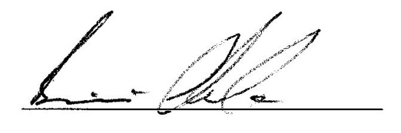

Brian Clarke.

Date: 1st May 2014

# Research Question

By observing the characteristics of a vessel in three sea states (0, 3, 6) is it possible to simulate the landing of a VTOL UAV autonomously on the deck by observing infra-red beacons on the landing pad and their relative movement in three dimensional space?

Will this simulation be able to show that the application has in fact aided in this landing process?

By tracking the relative distance between the two simulation models can the decent of the UAV be controlled?

# Terminology

## Abbreviations

|  |  |
| --- | --- |
| 2D | Two Dimensions |
| 3D | Three Dimensions |
| 6DoF | Six Degrees of Freedom |
| CCD | Charge Coupled Device – e.g. Camera sensor |
| CoG | Centre of Gravity |
| CPU | Central Processing Unit |
| GM | Metacentric Height |
| GPS | Global Position System |
| GPU | Graphics Processing Unit |
| INS | Inertial Navigation Sensor |
| IP/TCP | Internet Protocol – Transmission Control Protocol |
| MRAC | Model Reference Adaptive Controller. |
| PC | Personal Computer, either desktop or laptop. |
| RPAS | Remotely Piloted Air System |
| SDK | Software Development Kit |
| UAV | Unmanned Aerial Vehicle |
| UDP | User Datagram Protocol |
| VTOL | Vertical Take Off and Landing |
| VBN | Vision Based Navigation |

## Descriptions

|  |  |
| --- | --- |
| Centre of Gravity | One point in the ship where mass is equal in opposite directions for all 3 axes |
| Heave | Vertical motion in the direction of the y axis |
| Pitch | Rotation about the x axis |
| Roll | Rotation about the z axis |
| Sea State | Douglas Sea Scale/State – This is a number devised by Captain H.P. Douglas CMG, RN in 1929 to estimate the roughness of seas and gives a range of the expected wave heights (Met Office, 2010). The full chart can be seen in Appendix 1 |
| Surge | Thrust in the direction of the z axis |
| Sway | Lateral motion in the direction of the x axis |
| Yaw | Rotation about the y axis |

# 

# Assumptions and Exclusions

It is assumed that the flight characteristics of a VTOL UAV are similar to those of its manned equivalent, all other parameters being equal. This is solely for the purposes of discussion.

When the simulated image of the beacons on the ship are generated there is no allowance made for lens distortion or any lens refraction issues that may or may not occur in a single or array of lens elements. For the purposes of this project implementation a fixed point coordinate is used as the focal point of the camera simulation. Also the beacons are assign single pixel values rather than what would normally be expected in a real image of infrared sources.

The project does not allow for yaw and sway motions of the ship (rotation about the vertical axis y and lateral sideways motion) it was assumed for the purpose of this project that these would be negligible.

No forward motion was applied to the ship, mid-sized UAV are substantially faster than ships and it was felt that they should not have an issue matching the velocity of the ship. This was however mainly a decision made based on the scope of the project.

Again for project scope reasons the effects of wind, drag and turbulence as they act on the two vessels, and the pitch and roll motions of the UAV model are excluded from the project implementation.

# 1 Operational Goals

## 1.1 Introduction

Unmanned aerial vehicles (UAVs) are used extensively in the military and civil sectors for a multitude of tasks including scientific endeavours, environmental data collection and military reconnaissance. Vertical Take Off and Landing (VTOL) UAV’s have an advantage over fixed wing UAV’s in that they can take off and land from any flat surface large enough, within safe operational parameters, to accommodate the vehicle. This has insured the VTOL UAV’s place in maritime operations. However landing at sea can present its own challenges if (as shown below in Figure 1) the poise of the landing platform is in a constant state of change. The issue is compounded by the helicopter position and motions relative to that of the ship. It was reported in 2012 that the first fully autonomous landing of a VTOL UAV on the deck of a ship was successfully achieved by Boeing and NovAtel in July of that year (NovAtel, 2012). This highlights the relative infancy of this new technology and is the subject of this document.

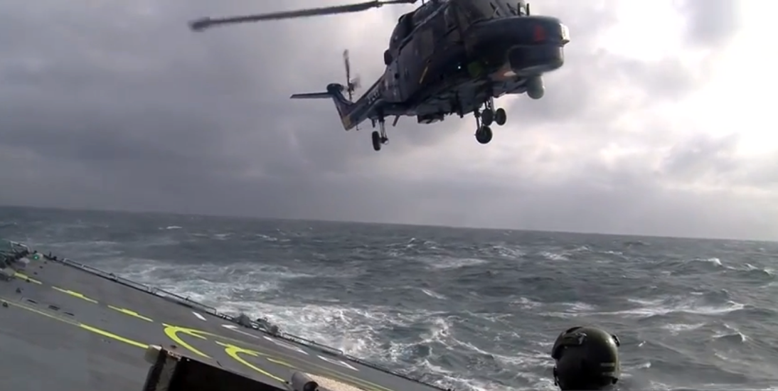

Figure 1. Helicopter landing on the deck of a ship in rough seas.

(Prism Defence, 2010)

## 1.2 Maritime UVA Mission Goals

In order to complete a safe mission a UAV must take off, achieve its primary objective, return to the ship and complete a safe touchdown. During this flow of events there are many factors that have a bearing on the success or failure of the assignment. These include climatic wind conditions, the endurance (maximum operational time) of the UAV, the sea state the ship is operating in, the distance to the mission goal, and the relative speeds and directions of the ship and UAV. For a given set of determining factors, and operator’s experience, the UAV pilot will decide on the feasibility of a successful mission and act accordingly.

## 1.3 Ship Interception

In order to satisfactorily complete the mission a UAV must perform the main objective and return to the ship from which it commenced its journey. The UAV is in live contact with the UAV pilot and the ships navigational system therefore the distance and trajectory of an intercept path are calculated.

This optimum intercept path (see figure 2) is calculated based on the ships current bearing and speed, data from the UAVs Inertial Navigation Sensor (INS) system, the GPS coordinates of both ship and UAV and the UAVs relative speed when present climatic conditions have been accounted for. These calculations are computed regularly and any corrective measures are implemented as soon as detected.

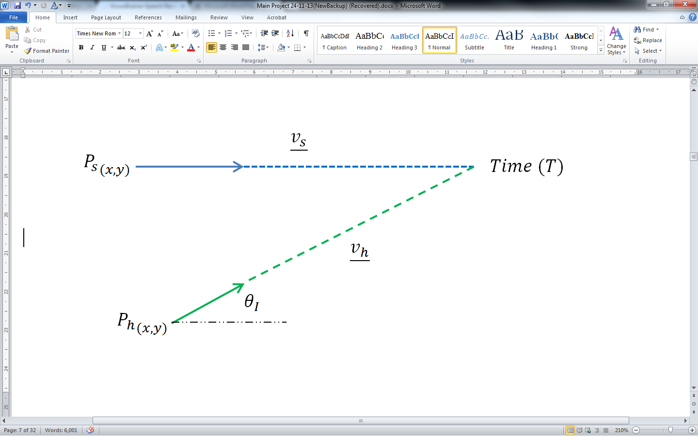

## 

Figure . Vector line diagram for the intercept path between a helicopter and a ship

Where;

$P_{s}$ is the present location of the ship,

$P_{h}$ is the present location of the helicopter,

Time (T) is a moment in time when an interception is possible assuming interception is possible,

$\underline{v_{s}}$ is the known velocity of the ship,

$\underline{v_{h}}$ is the known velocity of the helicopter, and

$θ_{I}$ is the unknown intercept angle relative to the ships trajectory.

Assuming the ship and helicopter meet at some point in time (T) then;

|  |  |  |
| --- | --- | --- |
|  | $$P_{s}+ \underline{v_{s}}T=P_{h}+ \underline{v_{h}}T$$ | eq. 1 |
|  | $$P_{s}- P_{h}=T( \underline{v_{h}} - \underline{v_{s}})$$ | eq. 2 |

Equation 2 can be extrapolated out in its x and y coordinates and squared to find two equations in T with other known variables;

|  |  |
| --- | --- |
| $${P_{s_{x}}}^{2}+ {P_{h_{x}}}^{2}+ {Tv_{s_{x}}}^{2}-2P_{s_{x}}P_{h_{x}}+2P_{s_{x}}Tv_{s_{x}}-2P_{h_{x}}Tv_{s_{x}}=T^{2}{{speed}_{h}}^{2}{Cos}^{2}θ_{I}$$ | eq. 3 |
| $${P_{s_{y}}}^{2}+ {P_{h_{y}}}^{2}+ {Tv_{s_{y}}}^{2}-2P_{s_{y}}P_{h_{y}}+2P_{s_{y}}Tv_{s_{y}}-2P_{h_{y}}Tv_{s_{y}}=T^{2}{{speed}_{h}}^{2}{Sin}^{2}θ_{I}$$ | eq. 4 |

If the assumption is made that the ships starting point is 0,0 and its traveling along the x axis, and knowing that;

$${Cos}^{2}θ_{I}+ {Sin}^{2}θ_{I}=1$$

Then if the two equations 3 and 4 are added;

|  |  |
| --- | --- |
| $${P_{h_{x}}}^{2}+ {P_{h_{y}}}^{2}+ {Tv_{s_{x}}}^{2}+ {Tv_{s_{y}}}^{2}-2P_{h_{x}}Tv_{s_{x}}- 2P_{h_{x}}Tv_{s_{x}}=T^{2}{{speed}_{h}}^{2}$$ | eq. 5 |

From equation 5 a value for (T) can be found that satisfies the other equations 3 or 4 and so the intercept angle $θ_{I}$ relative to the ship can be calculated.

## 1.4 Hover over Deck

When the UAV has intercepted the vessel and landing is imminent, it may be necessary for the UAV to maintain a hover position a safe altitude above and slightly to the rear of the ship. At this juncture the UAV should match the ships bearing and speed and remain at its present altitude until it is time to begin final approach. At this point the UAV may have entered the operational envelope of the ship and could be prone to adverse effects on stability as it deals with the air wake of the ship and changes to the air vortices that provide lift to the aircraft. As the environmental factors that govern the intensity and fluctuation of the air wake are variable it would not be advisable to remain in the air wake of the ship any longer than necessary. If the landing pad on the deck of the ship is obstructed for any reason and landing is unadvisable, the UAV should ascend out of the ship’s turbulence and defer landing until the situation is resolved.

## 1.5 Landing

“Landing a UAV is the most critical and accident prone phase of the flight” (Din, et al., 2012). There are additional factors to be considered as the UAV closes the distance between itself and the ship.

* The motion of the ship in six degrees of freedom (6DoF) as it reacts to the disruptive forces induced by the waves as they strike the ship. The two motions that have the greatest bearing on a successful landing are roll and pitch (discussed further in section 2.3 The Moving Platform).
* The climatic winds and subsequent turbulence generated as winds traverses the deck of the ship.
* The flight dynamics of the UAV can change as it nears touchdown. The air wake below the main rotors begins to interfere with the normal operational vortex of the rotors which in turn can lead to reduced rotor efficiency. If not checked the rate of decent can increase and landing can become extremely hazardous (Padfield, 2007).
* Any masts, railing, antennas or other obstacles the may impede the helicopters approach and corrective action will need to be taken.

All these factors must be considered to insure the landing phase and touchdown of the UAV are performed in as safe an operational envelope as possible.

The factors that influence the landing envelope and the processes involved in landing the helicopter are shown below in figure 3, which also includes a proposed Model Reference Adaptive Controller (MRAC). This controller bases the output to the flight controllers on the system inputs and also the previous MRAC outputs. This controller system provides a degree of “stable control during parameter uncertainty” (Kamalasadan & Ghandakly, 2011) and is discussed further in section 3.7 The UAV Controller.

## 1.6 Summary

There are many factors that influence the performance of a VTOL UAV as it attempts to land on the deck of a ship. The system proposed will produce a mathematical model for the elements highlighted in the diagram of systems, shown below i.e. UAV Camera, Image Processer and MRAC. The system will interpret the coordinates of the infra-red beacons as they might appear on a 2D plane representative of an image acquired by a camera located on the under carriage of the UAV. The coordinates will then be passed to the controller which will decide on the next course correction, if any, based on all the available inputs, and also the last set of outputs the controller provided to the flight controls.



Figure 3. Landing processes overview for the proposed system

# 2 Operational Characteristics of the Ship

## 2.1 Overview

There are many ships and other ocean going vessels ‘battling the seas’ around the globe at any moment in time. They all need to overcome the adverse factors that can hamper their progress. The main force that acts on a ship as it operates at sea is the power, frequency, direction and height of the waves it encounters. To a lesser extent the force of the wind is also a factor in that it can influence the profile of the waves as they strike the ship. How a ship or another vessel responds to these forces is dependent on the craft’s design characteristics and buoyance at that time.

## 2.2 Waves and Sea States

As an ocean going vessel carries out its operational goals it is subjected to the forces of the sea and its local environment. The main forces acting on a vessel (excluding thrust) are those associated with waves and the ships reaction to its instability relative to the center of gravity and buoyancy characteristics of the vessel.

In 1929 Captain H.P. Douglas CMG, RN estimated a set of codes to describe the roughness of seas and give a range of the expected wave heights (Met Office, 2010). The full chart can be seen in Appendix 1. These classifications range from Sea State 0 – 9 with respective wave heights of 0m to above 14m.

Waves can also be classified by their type and the table below shows the criteria for each type of wave.

|  |  |  |  |
| --- | --- | --- | --- |
| Name | Typical Periods | Wave Lengths | Forcing Mechanism |
| Ripples | <0.2 sec | 10-2 m | wind on sea surface |
| Sea | 0.2 – 9 sec | 130 m | wind on sea surface |
| Swell | 9 – 30 sec | 100s of metres | wind on sea surface |
| Tsunamis | 15 minutes – 1 hour | 100s of km | seismic |
| Tides | Several hours | 100s – 1000s of km | gravitational |

Figure 4. Table of Wave types and their characteristics

(Florida Centre for Instructional Technology, 2005)

Ripples are the smallest of the various types of waves and are generated as a response to light winds acting on the surface of the ocean. Sea waves are generated by stronger local winds as they act on the surface and can travel in various directions and with various speeds. Swell waves on the other hand tend to travel long distances in one direction. They are more regular in amplitude and wavelength and are normally a response to climatic conditions far away. Tsunamis and tides are other types of waves and occur as a response to global forces (Florida Centre for Instructional Technology, 2005). They also suggest that to aid in the study of waves, ideal sinusoidal shaped wave structures should be considered. A sine curve can be discribed as:

$$y(t)=A*sin⁡(2πft)$$

where:

$y(t)$ = the coordinate value for y at a given time t.

$t$ = the time interval during a single sinusoidal wavelength.

$A$ = amplitude of the wave, measured from the mean value of the wave i.e. center line.

$f$ = frequency of the wave, the number of times per second the wave completes a full cycle.

For a complete study however the apparently random differences in amplitude, wavelength, and frequency within the Sea State ranges would need to be accounted for, to develop a more complete model.

Individual wave types also have various characteristics based on their stage of development. During the lifecycle of a wave, it is either developing, fully developed or decaying. A wave can be said to be fully developed “when wind speed matches wave crest phase speed” (Techet A. H., 2005). A wave may travel for hundreds of miles in this state but it will start to decay if the other forces acting on the wave start to overcome the kinetic energy of the wave.

## 2.3 Wind

As described before wind plays a large part in the generation of waves which affect the vessel. To a lesser extent wind can have an effect on the performance of a ship. This effect on performance would normally not be directly attributable to the ship itself but rather the crew operating on the ship and their ability, or lack of, to perform their individual tasks. In extreme conditions however the winds impact on the ship may become more pronounced e.g. a very strong cross wind may contribute to the roll of a ship in those conditions.

One of the main concerns with wind is its interaction with the ship’s superstructure. The airwake and turbulence generated by the vessel as it passes through wind should be considered when deciding if it is appropriate to proceed with the launch or recovery of a UAV. As reported by (Snyder, 2012) wind’s “turbulent kinetic energy is significantly greater in the superstructure wake than in the free stream flow observed by the bow”. This is discussed later in this chapter during the section on the operational envelope,

## 2.4 The Moving Platform

A vessel on the surface of the ocean moves with six degrees of freedom (6DoF) and in accordance with the forces acting on it (see figure 5), which can be both external and internal. The two main external forces acting on a ship in the ocean are waves and gravity. There are others, such as wind and drag but both these are not as influential on the motion of the ship as waves and gravity. The internal forces acting on a ship are thrust, the reaction to instability relative to buoyancy and CoG and rudder induced turning moments. The diagram below gives a visual representation of the 6DoF for a vessel in water.

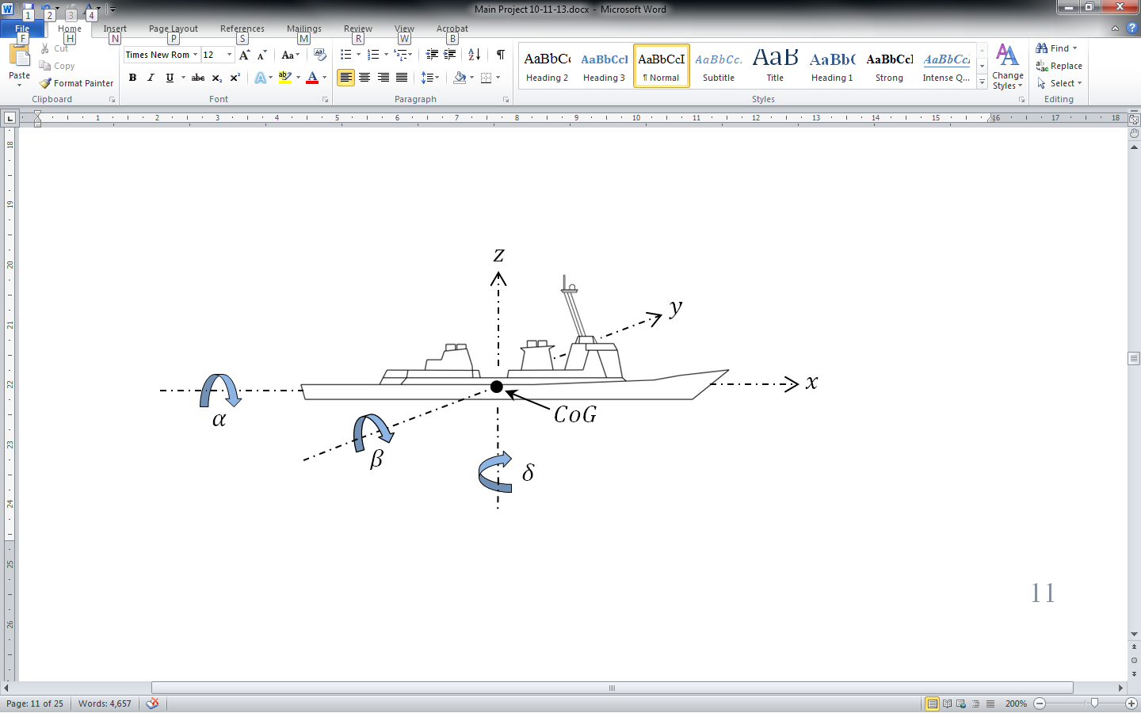

Figure 5. Diagram Showing 6 DoF of an ocean going vessel

|  |  |  |
| --- | --- | --- |
| Name | Symbol | Description |
| Surge | $$z$$ | Thrust in the direction of $+/-$ $z$ |
| Sway | $$x$$ | Lateral motion in the direction $+/-$ $x$ |
| Heave | $$y$$ | Vertical motion in the direction $+/-$ $y$ |
| Roll | $$α$$ | Rotation about the $z$ axis either $+/-$ |
| Pitch | $$β$$ | Rotation about the $x$ axis either $+/-$ |
| Yaw | $$δ$$ | Rotation about the $y$ axis either $+/-$ |
| Centre of Gravity | $$CoG$$ | One point in the ship where mass is equal in opposite directions for all 3 axes. |

Figure 6. Table of values for 6 DoF diagram

## 2.5 The Operational Envelope

Modern ocean going vessel are designed to handle a variety of different sea conditions and the larger vessels in particular would be expected to be able to handle all but the very extremist of weather conditions. While the poise of a ship is in flux there are a number of forces acting and reacting on the vessel, determining the ships responses to it local environment. Some the elements involved in this interaction include:

* Buoyancy – According to Archimedes’ Principle, a vessel immersed partly or completely in a fluid receives lifting force equal to the weight of the fluid displaced by the vessel. Buoyancy acts vertically upwards (see figure 7).
* Gravity – The earth’s gravitational force acts in a vertically downward direction and when the vessel is completely stable cancels out the buoyancy force.
* Wave forces – The force of large waves acting on the ship can have dramatic effect to the motion of a vessel. Along with amplitude and frequency, the direction of the waves relative to the ship can have very different effects on the motion characteristics of the ship.
* Ship Characteristics – The size, center of gravity, center of buoyancy, metacentric height, thrust capabilities of the ship and any motion damping fins all have effect on the motion of the ship as it proceeds with its objectives.

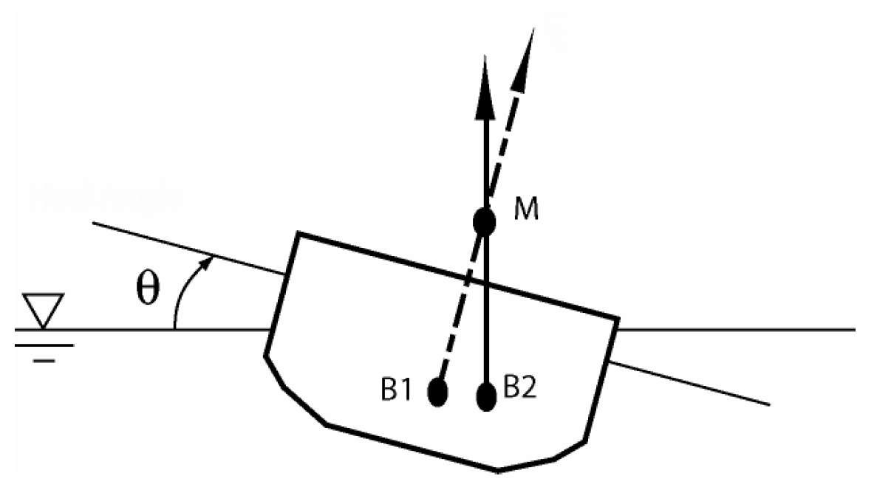

Figure 7. Section of hull diagram showing changes to buoyancy

(Techet A. H., 2004)

Where for a given roll angle of θ;

B1 = Centre of Buoyancy when the vessel was stable and horizontal.

B2 = Centre of Buoyancy after roll to angle θ

M = Metacentre

Techet explains that a ship’s metacentric height (GM) is the distance between the vessel centre of gravity and the vessels metacentre. The larger the value for GM the ‘stiffer’ the ship will be in response to the forces promoting roll motions on the vessel. The opposite is also the case if the GM is relatively small with less force needed to impose a roll on the vessel.

## 2.6 Summary

The poise of a ship at sea is in a state of constant change. Each type of vessel will have its own set of responses to the external forces acting on the vessel as it continues with its objective. In particular the action – reaction relationship between the force of the waves the vessel encounters and the vessel’s buoyancy and righting force, plays a large part in the way a ship responds. Also the direction of the waves relative to the heading of the ship will have different effects i.e. a ship heading directly into waves will have greater pitch angles and smaller roll angles when compared to a ship which is travelling parallel to the wave and being struck side on. If an aircraft is attempting to land on the deck of a ship these factors would need to be considered.

# 3 Operational Capabilities of the UAV

## 3.1 Overview

Helicopters and VTOL UAVs by extension are by nature unstable, they operate with six degrees of freedom in an environment of nonlinear dynamic variables and coupled with this a helicopter’s central body of mass is not capable of sustained flight. During flight a helicopter has principally two states, motion and hover of which hover is the most challenging. Without momentum and with the nonlinear forces acting on the aircraft, holding state involves constant change. This is a balancing act performed by a pilot or a navigational control unit.

According to (Federal Aviation Administration, 2012, pp. 2-2) once a helicopter leaves the ground it is subject to “four aerodynamic forces; thrust, drag, lift and weight” (see figure 8).

* Thrust is the self-generated force that propels the aircraft in the desired direction normally in a forward motion “parallel to the longitudinal axis”.
* Drag is resistance to thrust, it can be generated in a number of ways including; poor aerodynamics of a payload or sensory bank, wind direction and climatic or operational air turbulence. “Drag opposes thrust and acts rearward parallel to the relative wind”.
* Weight is the total mass of the operational aircraft and the forces it exerts on the aircraft as a result of gravity. “It opposes lift and acts vertically downward through the aircraft’s center of gravity (CoG)”.
* Lift is generated as the helicopter’s rotors pass through the envelope of air above the cockpit. This rotation generates negative pressure above the rotors and positive pressure below the rotors so leading to the upward vertical motion. Lift is used to counteract weight during flight and acts vertically up from the CoG.

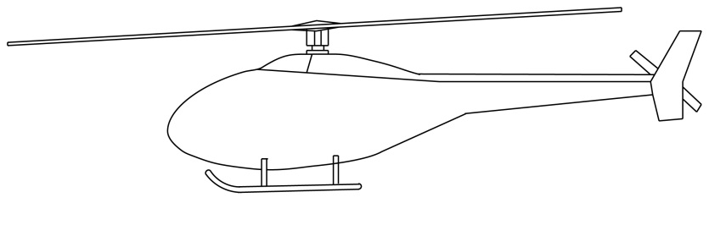

Lift

Drag

Thrust

Weight

Figure 8. Forces acting on a helicopter in flight

## 3.2 Wind

Of all the nonlinear dynamic forces affecting a helicopter in flight wind is the force that needs the most consideration; weight is probably the largest force but is relatively constant. The flight path of the helicopter or UAV relative to the climatic winds can have a bearing on the performance of the vehicle in question. As (Biven & Guercio, 1987, p. 8) explains a helicopter has a tendency to align itself with the direction of the relative wind, this needs to be counteracted with the tail rotor and is referred to as “Yaw Weathercock Stability”. Also the wind turbulence generated by the ships air wake, as the aircraft approaches the ship can have an adverse effect on the air vortices the rotors rely on for stable flight.

These winds can have a greater effect on smaller UAVs. Referencing Newton’s Second Law of Motion, F = ma, the force of the wind relative to the UAV’s mass and acceleration is greater than that acting on a manned helicopter.

## 3.3 Performance

There are a wide variety of VTOL UAVs in civilian and military use around the world each with its own unique characteristics. Vehicle size, shape, payload, engine power, fuel consumption and design all play their part in determining the performance of the helicopter. Coupled with this is the unique environment the aircraft is deployed in each time it carries out an operation. Rotomotion’s SR200 Helicopter UAV (see figures 9 & 10) is a mid-range UAV achieving up to 5 hours of flight and with a maximum payload of almost 23kgs, details listed below. This UAV would meet a lot of the needs for a maritime surveillance operation.

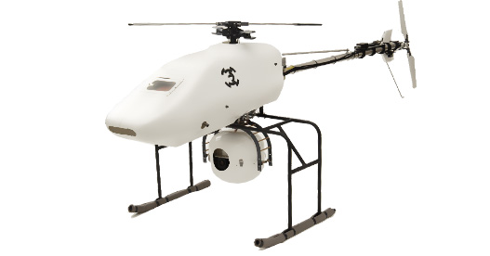

Figure 9. Rotomotion VTOL UAV

(Rotomotion, 2011)

|  |  |
| --- | --- |
| UAV Specification Item | Specification |
| Length | 2790 mm |
| Width | 760 mm |
| Height | 860 mm |
| Main Rotor (M/R) Diameter | 3000 mm |
| Tail Rotor (M/R) Diameter | 700 mm |
| Dry Weight | 25 kg |
| Fuel Capacity | 2 litres (18 litres available) |
| Engine | 150cc, 2-stroke engine |
| Generator | 800 W, 24 V alternator |
| Climb Rate | 2 ms-1 |
| Maximum Speed | Up to 60 km/h |
| Endurance | Up to 5 hours |
| Maximum Payload | 22.7 kg |
| Operating Ceiling | 1,500 m |

Figure 10. Rotomotion’s SR200 Helicopter specification

(Rotomotion, 2009)

A larger UAV, predominantly in military use, is the Schiebel Camcopter S-100 (see figures 11 & 12). This UAV has been deployed by the French, Italian, Russian, and United Arab Emirate militaries. A partnership deal between Schiebel and Boeing helped expose the S-100 to the American market, where it was also presented to “U.S. Army Special Operations Command (USASOC) at Ft. Bragg” (Schiebel, 2009)

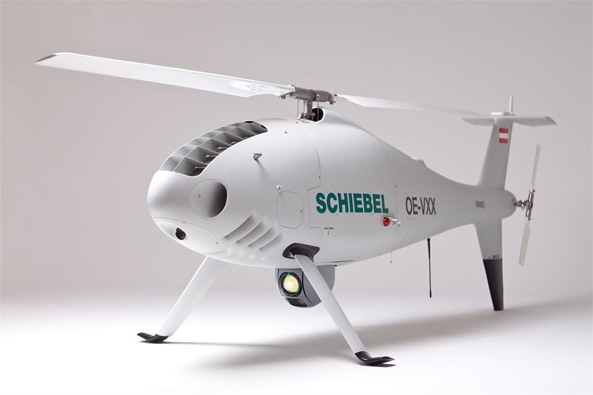

Figure 11. Schiebel Camcopter S-100 VTOL UAV

(Schiebel, 2013)

|  |  |
| --- | --- |
| UAV Specification Item | Specification |
| Length | 3110 mm |
| Height | 1120 mm |
| Main Rotor (M/R) Diameter | 3400 mm |
| Dry Weight | 110 kg |
| Maximum Payload | 50 kg |
| Fuel Capacity | 57 litres |
| Engine | 41 kW (55 HP) rotary engine |
| Maximum Speed | Up to 240 km/h |
| Endurance | Up to 6 hours |
| Operating Ceiling | 5400 m |
| Wind (takeoff and landing) | Up to 46 km/h |
| Data Link Range | Up to 180km |

Figure 12. Schiebel Camcopter S-100 specification

(Schiebel, 2013)

## 3.4 Navigation

All aircraft have an Inertial Navigation Systems (INS) and VTOL UAVs are no different. The deviation though may be in the destination of that information. If the UAV is fully autonomous then the information is sent to the UAVs flight control system where the system determines the next control response to be undertaken. However if the UAV is under the control of a pilot then the INS information will be displayed on the pilots interface, which may be many kilometers away, for example Schiebel’s Camcopter S-100 can communicate with its pilot up to 180 km away (Schiebel, 2013).

The information processed by an aircraft’s INS can include; altitude, heading, pitch, roll, velocity and GPS. These values in conjunction with the mission objectives will determine the UAVs next course of action. Some INSs also employ secondary or redundant systems as fail safes. For example the KN-4072A unit, available from Kearfoot, also records barometric altitude which can be included in the “vertical loop in the absence of valid GPS data” (Kearfoot, 2011), which could be extremely important if a hostile force is interfering with a GPS signal.

Other navigational tools that are deployed on some UAVs include; radar, way points (the systems generate their own longitudinal/latitudinal points for the return leg of the operation) Ethernet, cameras, and high altitude imagery.

Combined, this array of sensors, receivers and equipment is known as the sensory bank and is often fitted under the aircraft away from the engine and rotors, reducing vibration as much as possible.

## 3.5 Response Times

The response time of helicopters and UAVs to flight control changes is difficult to provide. There are a number of factors that will affect the performance characteristics of the aircraft. These include; mass and payload, CoG and its location, wind and its direction, thrust at the time of control change and momentum relative to the desired control change. For example the helicopter or UAV may respond almost instantaneously, if the desired control change corresponds to the relative wind direction, however the same control applied in the opposite direction may have little or no impact if the force applied is not substantial enough to overcome the force of the relative wind

In his doctoral thesis on flight control for VTOL UAVs Yuan observed the dynamics of u, v and w the longitudinal, lateral and vertical velocities (see figure 13). When a closed-loop controller was implemented, the expected change rates for u, v and w were recorded. These are shown below.

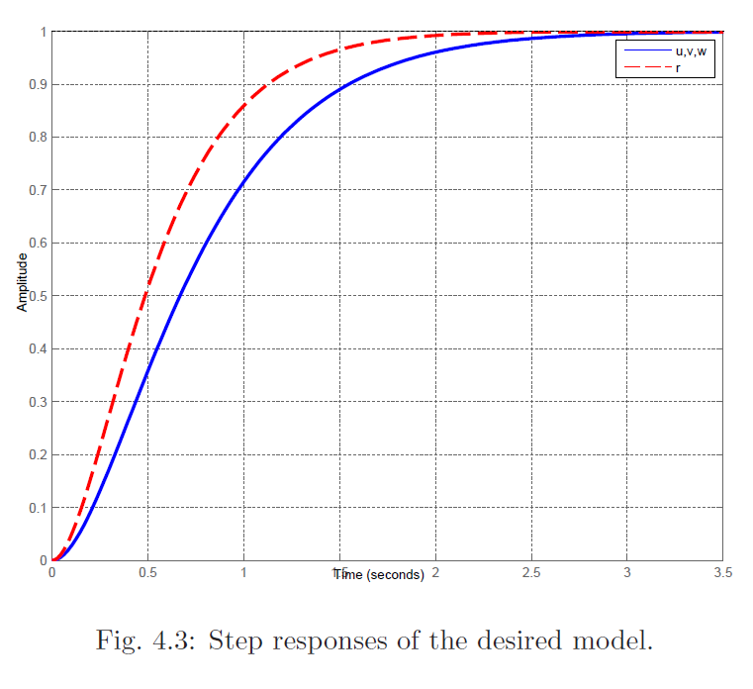

Figure 13. Yuan's finding for response times versus changes in vector u,v and w

(Yuan, 2013, p. 50)

As can be seen from the plot the rate of changes for the vector forces u, v and w are nonlinear. This is expected as the internal and external forces that affect these rates of change are also nonlinear e.g. acceleration, momentum, climatic and turbulence induced winds etc.

As the aircraft approaches the point at which a required alteration is nearing completion it is common for a flight controller to apply a dampening effect to the flight controls. In Yuan’s implementation he also investigates the need to “increase the damping ratio of the closed-loop system as the system output approaches the target reference to reduce the overshoot” (Yuan, 2013, p. 15)

Another factor in the control of UAVs (piloted) is the human response times which (Biven & Guercio, 1987, p. 45) states is “0.3 sec, which is representative of the human neuromuscular time delay”. This delay could be further extended if the pilot is under pressure to perform multiple tasks at once which is normally the case when operating the controls of a helicopter UAV.

## 3.6 Camera

Like the sensory array available to the UAV there is also a wide variety of cameras that are available to the aircraft. One of the only disqualifying factors would be the net mass of the camera and the UAVs payload capabilities. A high end camera system is supplied by Hood Tech Vision (see figures 14 & 15). The 11EOIR1 is a “mid-wave infrared and electro-optical imaging system … designed for small unmanned aerial vehicles” (Hood Tech Vision, 2013) selected details are below.

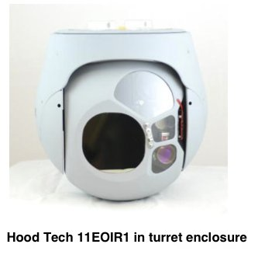

Figure 14. Hood Tech Vision - 11EOIR1

(Hood Tech Vision, 2013)

|  |  |
| --- | --- |
| Specification Item | Specification |
| Field of View | MWIR: 2°-25° EO: 1.7°-57° |
| Pixels | MWIR: 640 x 480 EO: 720 x 480 |
| Wavelength | MWIR: 3-5 µm EO: 400-900 nm |
| Zoom (optical) | MWIR: 12.5X EO: 36X |
| Communications | Nominal: Serial communication, 57,600 bps |
| Video | Composite NTSC |
| Weight | 5,700 g with enclosure |

Figure 15. Hood Tech Vision - 11EOIR1 specifications

(Hood Tech Vision, 2013)

## 3.7 The UAV Controller

The proposed control system for the UAV simulation will model a closed loop system where feedback is reviewed and alterations to commands are made if required. It is also proposed to develop this closed loop system as a Model Reference Adaptive Controller (MRAC). The MRAC will base any required changes on the controller’s previous commands and the controller’s reference model or baseline. These systems are suited to the task in hand due to their “improved performance and increased robustness to uncertainties by virtue of their ability to adjust control parameters” (Thompson Dydek, 2010). The controller can make allowances for any momentary unknown parameter which can be the case when dealing with the nonlinear variables in the UAV operational envelope.

## 3.8 Summary

Helicopters and VTOL UAVs are naturally unstable aircraft. Their operation is affected by a list of nonlinear variables as they operate in six degrees of freedom. That been said they are ideally suited for certain operations that cannot be performed by winged aircraft. One of these is landing in a confined area. This project proposes to examine the interaction between some of these nonlinear variables and the projected movements of a UAV in 3D space as it approaches touchdown on the deck of a ship. Although the movement and responses of the aircraft are hard to establish definitively, an operational response envelope of 0.5ms-1 in all 3 axes of 3 dimensional space is expected. This expectation is a minimum would be relative to any acceleration or momentum already acting on the aircraft.

# 4 Final Approach

## 4.1 The Four Phases

As discussed by (Shin, You, & Shim, 2013) and (Fang, et al., 2003) the landing of a helicopter on the deck of a ship can be described in four distinct phases. The helicopter is in “Tail-Chasing Mode” when there is greater than 350m between the helicopter and the ship. When the helicopter enters the range between 350m and 50m, the aircraft is in the “Approach Mode”, at this stage it is also recommended to lower altitude to 30m. To proceed, the helicopter then enters the “Descending Mode” reducing altitude, matching velocity with the ship and finally touching down in the “Landing Mode”.

## 4.2 Landing Approaches

With reference to the landing of a helicopter, Fang, et al. also goes on to explain from page 1-18 that to their “knowledge there are six different procedures which are being applied worldwide”. Three of the main procedures are described as;

“Fore/aft or forward facing procedure”

“Relative-wind or into wind procedure”

“Cross-deck procedure”.

When deciding on a desired and/or required landing approach the polit of a helicopter must consider many factors, one of the main considerations when evaluating a flight path is the crosswind and the direction of the crosswind relative to the ship (Shin, You, & Shim, 2013, p. 771).

## 4.3 Touchdown

When the UAV approches touchdown it can be in a percarious state. The aircraft can be prone to slip and rotational momentium as the movements of the ship are now imposed on the aircraft. If a helicopter in the process of landing, touches down on one side while still amost airbourne it is possible the aircraft may ‘slip’ laterally. This issue could then be compounded if the landing gear strikes an obstacle (see figure 16), adding momentum about the landing gear pivot point.

“When the helicopter comes in contact with the ground and a new pivot point is established the moment of inertia about the roll axis increases nearly five-fold due to this displaced pivot point” (Lobik, 2003). The rotational momentum of the ship can compound this issue, but it can also have adverse affects on the aircraft alone. If the centre of gravity and the tipping point of the aircraft approach each other as the ship rolls the aircraft will be prone to dynamic rollover. Any state of instability will continue until the aircraft has lost suffient lift to insure gravity will hold it in place on the deck of the shipor the aircraft mechanically secured or stowed away.

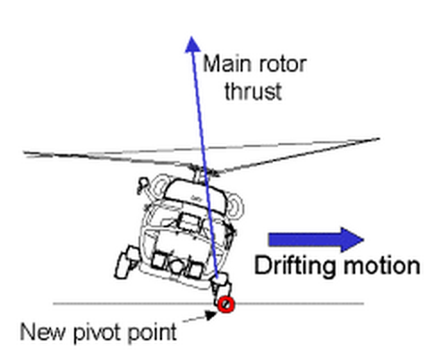

Figure 16. Lobik's diagram showing lateral ‘slip’ as a helicopter is landing or taking off

(Lobik, 2003)

## 4.4 Summary

The final stages of a helicopter or UAV flight, as it attempts to touch down on the deck of a ship involve complex operations. The skill and coordination of the pilot or UAV operator must be up to the task at hand. The proposed system will focus on this stage of VTOL aircraft flight, and in particular UAV landings.

# 5. Commercial and Academic Landing Assist Systems

There are a number of commercial systems on the market that offer similar functionality as that proposed for this project. There are also many academic papers that have investigated the issues discussed here. The commercial products discussed below use positioning systems either local or global. The academic papers outlined in section 5.2 employ various methods to aid in the landing.

## 5.1 Commercial Systems

Astrium’s ‘DeckFinder’ system uses deck mounted “Pseudo-Satellites” to provide a local positioning system which operates without the need for Global Positioning Systems. The system delivers positional accuracy of 20cm at a rate of up to 15Hz to a range of up to 1.1km (Astrium, 2013).

NovAtel have developed an “Automated Flight Control System” which uses their navigational systems to autonomously land a drone helicopter. These navigational systems use GPS and INS data from the ship and the UAV. This system was tested successfully in conjunction with Boeing’s H-6U VTOL UAV on 4th July 2012 when the UAV was autonomously landed on the deck of a moving ship (NovAtel, 2012).

## 5.2 Academic Systems

At the 2013 International Conference on Unmanned Aircraft Systems, (Shin, You, & Shim, 2013) presented a paper which evaluated an algorithm for the landing of a UAV autonomously. The paper investigates the use of a Time-Delay Control and a MatLab simulation to validate the results. The algorithm makes allowances for crosswind, and the different landing phases a VTOL UAV must negotiate to touch down successfully. The performance of the time delay controller, which is modelled on a model reference adaptive controller, is compare to the results from a conventional proportional derivative controller. Shin’s finding showed that “the landing system generated optimal landing procedures based on the Navy procedures”.

Another paper presented at the Unmanned Aircraft Systems conference by (Sanchez-Lopez, Saripalli, Campoy, Pestana, & Fu, 2013) discusses the use of a colour camera fixed to a UAV to aid in the its landing on the deck of a ship. The UAV in this case also uses sonar to determine the difference in altitude between the ship and the aircraft. Their simulation for the ship was based on an Oliver Hazard Perry Class FFG Frigate operating in sea state six. The system uses image recognition and extraction to acquire the optimal landing coordinates and the model’s performance was satisfactory in “the first steps required to achieve a solution to the challenge of autonomously landing on a ship”.

In the IEEE journal, Transactions on Robotics (Herissé, Hamel, Mahony, & Russotto, 2012) reported on the findings of their paper on VTOL UVA landings on a moving target using optical flow. Their control algorithms used the optical flow measurements obtained from a camera fixed to the centre of mass of the UAV. They explained that the results “show that the proposed scheme is effective” although it was observed that improvements in the response times for the camera would help improve the effectiveness of the closed loop controller.

In their paper Esmailifar and Saghafi propose a UAV landing system which employs a multilevel controller to track the target and land on a platform which moves with six DoF. This is achieved in two distinct phases, the “Supervisor level” which deals with intercepting the ship and the “Tracking level” which tracks the attitude differences between the aircraft and the ship. In evaluating the landing system’s performance the motion of the ship is modelled on a sinusoidal wave. They concluded that the performance of the simulation was satisfactory as “the helicopter is able to track the ship states in both landing phases” (Esmailifar & Saghafi, 2009).

## 5.3 Summary

There have been many academic papers on proposed landing systems for helicopters and VTOL UAVs but the same does not seem to be the case for their commercial equivalents. On 4th July 2012 NovAtel and Boeing claimed to have been the first to successfully land an autonomous UAV on the deck of a moving ship (NovAtel, 2012). This is surprising considering the level of research into this sector of aerial systems, and could indicate the complexity involved in implementing the research models in real life applications.

# 6. Project Design

## 6.1 Scope

This project will determine course correction of a UAV as it attempts to land, based on simulated images of the deck of a ship. To aid in this task infra-red beacons in a predetermined pattern will be analysed. It is expected that these course corrections will be generated in good time allowing for sufficient correction to the UAVs mathematical model. It is proposed to achieve operational responses for the UAV model of 0.5ms-1 in all 3 axes.

The ship will also be represented by a mathematical model and its movements displaying sinusoidal motion tendencies as it reacts to waves in Sea State 6. A dataset has been obtained for a list of ships operating in sea state 6 which is at the upper end of the operational envelope of the UAV. These datasets contain maximum angles of displacement and accelerations which will need to be transposed to 3D geometry relative to time.

It is planned to present the results as a simulated display in Unity where the UVA model will attempt to land by reducing the displacement between itself and the ship and ultimately resulting in a successful touchdown.

## 6.2 Estimate of Activities

1. Produce a working mathematical model of the ship relative to the dataset already obtained (McDonald, 1993).

2. Produce a working mathematical model for a UAV based on the performance characteristics stated above and relative to the ships motion.

3. Produce statistical dataset of the require control alteration for the UAV as it attempts to land on the ship, resulting in the touchdown.

4. Implement a comprehensive test plan to validate the system results.

4. Present the results in a visual display to confirm the finding of the project.

## 6.3 Risk Analysis

|  |  |
| --- | --- |
| Risk | Alternative Action |
| The dataset is for the motion of the ship was recorded in Sea State 6. This is at the upper limits for the operation of mid-sized UAVs and the results may be unsatisfactory. | If landing the UAV in this sea state proves problematic the expected motion of the ship will be altered proportionally to represent a lower sea state. |
| It is proposed to produce the mathematical models for the ship and helicopter with Unity and Visual Studio. Knowledge of Unity is limited and a steep learning curve is anticipated. | There are ample online resources to mitigate this risk. |
| The format for the presentation of the results has not yet been decided. | It is hoped to develop this project with two PCs that communicate via interconnected sockets. However as the scope for this project is significant and it is proposed to develop the implementation on one machine first. |
| The scope of the project as a whole is a risk as there are many nonlinear variables that need to be computed to achieve the ultimate goal. | Unknown and dynamic variables such as deck draft and wind turbulence could be assumed as near constants to help compute the models. |
| It may not be possible to randomly generate all the variable forces acting on the models as the application tries to process the datasets. | A more sterile version of the forces could be used; these though should still include the major variables. |
| At the time of writing this report it is not known if the hardware that will be used to deploy this project is powerful enough for the task in the time required. | If this turns out to be the case, processing demand could be lowered if certain minor or nominal variable forces are set as constants in the interest of evaluating the bigger issues. |

## 

## 6.4 Use Case Diagrams

### 6.4.1 Adaptive Control System Use Case Diagram



Figure 17. Use Case Diagram - Adaptive Control System

|  |  |
| --- | --- |
| Use Case | Receive Latest INS Data |
| Actor | INS Simulator |
| Description | The coordinates and rotations of the UAV relative to the spatial reference plane are received from the INS Simulator |
| Flow of Events | The INS posts new coordinate and rotation data on a looped basis. The controller records the new data received so it is available for evaluation. |
| Use Case | Receive Image Processor Data |
| Actor | Image Processor |
| Description | The image processor provides data on the location of the infra-red beacons relative to the image plane. |
| Flow of Events | The Image Processor post new coordinate data on a looped basis. The controller records the new data received so it is available for evaluation. |
| Use Case | Compute Course Correction |
| Actor | UAV Flight Controller |
| Description | Course correct data is posted from the adaptive control unit to the UAV flight controller. |
| Flow of Events | The adaptive control unit reads the INS coordinate data. The adaptive control unit also reads the image processor data and references the last set of outputs. Based to this data and the expected data patterns a decision on the next course correction is made. These corrections are then posted to the flight control unit. |

Figure 18. Use Cases - Adaptive Control System

### 6.4.2 Image Processor Use Case Diagram



Figure 19. Use Case Diagram - Image Processor

|  |  |
| --- | --- |
| Use Case | Process Latest Image |
| Actor | Camera Simulator |
| Description | The camera simulator provides bitmap images to the image processor as they are available on a looped basis. The image processor reads the images and records the coordinates displayed in the image. |
| Flow of Events | The Image Processor receives an image form the camera simulator. The image is the scanned using the search algorithm. When the coordinates are found they are recorded locally. |
| Use Case | Provide Image Data |
| Actor | Adaptive controller |
| Description | The image processor posts the image coordinates to the adaptive control system for evaluation |
| Flow of Events | As the images are processed the coordinates are posted to the adaptive control system. The image processor then repeats the process on a looped basis |

Figure 20. Use Cases - Image Processor

### 6.4.3 INS Simulator Use Case Diagram



Figure 21. Use Case Diagram - INS Simulator

|  |  |
| --- | --- |
| Use Case | Receive Latest Data |
| Actor | Adaptive Control System |
| Description | The INS simulator receives the last flight control requests from the adaptive controller and records the data locally. |
| Flow of Events | The INS system receives data from the control unit and persists it locally. This continues on a looped basis as the inputs are received from the control unit. |
| Use Case | Provide Latest INS Data |
| Actors | Adaptive controller  Camera Simulator |
| Description | The INS simulator posts the post the UAV coordinates to the adaptive control system and the camera simulator for evaluation. |
| Flow of Events | The INS simulator reads the data provided by the adaptive controller and adjusts the recorded coordinates for the UAV accordingly. These new coordinates are the returned to the adaptive controller and the camera simulator for evaluation. This process repeats on a looped basis. |

Figure 22. Use Cases - INS Simulator

## 6.5 High Level State Diagram



Figure 23. High Level State Diagram

## 6.6 System Architecture

It is proposed to use a three tier architectural design, consisting of a GUI presentation layer, a control layer and two business layers (see figure 24). The implementation of two business layers will provide a layer of separation between the business logic layers for the two models.

It is proposed to build the presentation layer as a collection of Unity (Unity, 2013) ‘scripts’. These C Sharp classes will be developed in the Visual Studio editor which is accessible directly from Unity. In order to harness the functionality of the Unity game engine, the presentation layer classes need to implement the Unity interface ‘MonoDevelop’. The implication of using Unity with this configuration is the difficulty testing this element of the project. The testing of ‘gameObjects’ and their relative motion in a virtual 3D space would involve substantial effort. As an alternative it is proposed to remove any business logic from presentation layer and implement it in the lower layers of the architecture. The lower levels of the architecture will not implement MonoDevelop and so NUnit (NUnit, 2013) or a similar testing framework will be available to the system.



Figure 24. System Architecture

## 6.7 Component Diagram

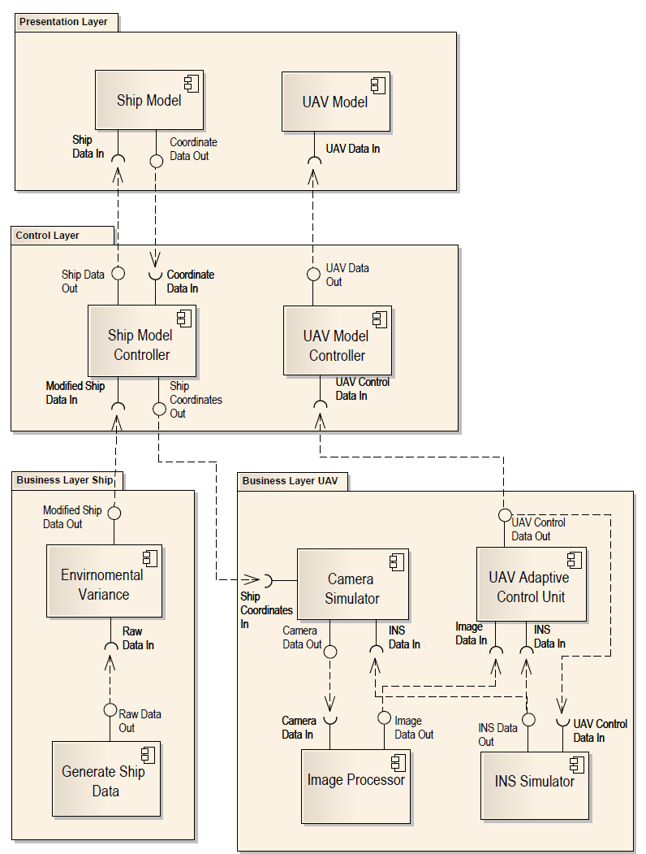

Figure 25. Component Diagram

## 6.8 Methodology

The research methodology for this project involved investigating previous works on related subjects, in particular white papers which were sourced on the internet. To this end, access to IEEE proved extremely productive. For reference purposes commercial product were reviewed and documented. Other information was sourced form reputable online sources including;

* MIT
* National Aeronautics and Space Administration
* North Atlantic Treaty Organisation
* United States Department of Transportation
* United States Navy
* UK, Met Office
* American Society of Naval Engineers

It is proposed to implement this project with a waterfall methodology. The system components will be developed and documented on a weekly basis and presented to the primary supervisor for evaluation. Alongside each project component, unit tests will be developed and then grouped into test suites where appropriate.

## 6.9 Test Plan

It is proposed to use NUnit as the test environment for this project. As discussed earlier in section 6.4 System Architecture, there are difficulties running unit tests against Unity game objects and how they interact with the scene that contains them. It is proposed to remove all business logic, where possible, from this layer and perform the required testing in the lower layers of the system. At the presentation layer manual test will be performed at a baseline of sea state 0 and also at the desired sea state 6.

To aid in the achievement of this goal it is proposed to implement a test plan which will include a suit of test for both the ship and UAV motions.

Ship Test Suite;

* Test the pitch of the ship is within parameters.
* Test the roll of the ship is within parameters.
* Test the yaw of the ship is within parameters.
* Test the surge (propulsion) of the ship is within parameters.
* Test the heave of the ship is within parameters.
* Test the sway of the ship is within parameters.

In the case of all the tests above, the movement of the 3D points allocated to the location of the infrared beacons will be tested.

UAV Test Suite;

* Response times for the controller outputs will be measured as the system processes the perceived pattern of the infrared beacons on the deck of the ship. There will be tests for each of the motions listed above.

Integration Test Suite;

* Tests will be deployed to measure the success of the interaction between the ship and UAV models.

Below is the test plan for the proposed project (see figure 29).

|  |  |  |
| --- | --- | --- |
| Test Number | Description | Expected Result |
|  | Non Test Framework Environment |  |
| 1 | Manual test of model at sea state 0 | Satisfactory touchdown |
| 2 | Manual test of model at sea state 6 | Satisfactory touchdown |
|  |  |  |
|  | Test Framework Environment |  |
| 3 | Test data generated for ship motion |  |
| 3.1 | Test sample data for heave | Below sea state 6 maximum values |
| 3.2 | Test sample data for roll | Below maximums for ship concerned |
| 3.3 | Test sample data for pitch | Below maximums for ship concerned |
|  |  |  |
| 4 | Test ship data following adjustments for environmental variance |  |
| 4.1 | Test sample data for heave | Within sea state 6 limits |
| 4.2 | Test sample data for roll | Within limits for ship |
| 4.3 | Test sample data for pitch | Within limits for ship |
|  |  |  |
| 5 | Coordinates for IR beacons |  |
| 5.1 | Test coordinates for heave | Within sea state 6 limits |
| 5.2 | Test coordinates for roll | Within limits for ship |
| 5.3 | Test coordinates for pitch | Within limits for ship |
|  |  |  |
| 6 | Test output from camera simulator |  |
| 6.1 | Test 3D – 2D conversion for coordinates | Pass the test previously verified data for comparison |
| 6.2 | Test simulated frame rate of the camera | 24 – 30 fps |
|  |  |  |
| 7 | Test output from Image Processor |  |
| 7.1 | Test 2D – 3D reconversion of coordinates | Pass the test previously verified data for comparison |
| 7.2 | Test new 3D coordinates relative to camera poise | Pass the test previously verified data for comparison |
| 7.3 | Test processing speed | 15 fps (commercial products) |
|  |  |  |
| 8 | Test the INS simulator |  |
| 8.1 | Test responses to changes to relative wind direction | Pass the test previously verified data for comparison |
| 8.2 | Test simulated GPS coordinates | Pass the test previously verified data for comparison |
| 8.3 | Test simulated inertial responses | 0.5ms-1 |
|  |  |  |
| 9 | Test Adaptive Controller |  |
| 9.1 | Test processing speed | 15 fps (commercial products) |
| 9.2 | Test Output control instructions | Pass the test previously verified data for comparison |

Figure 26. Test Plan

## 6.10 Prototype

To develop a prototype a number of different platforms were investigated. First the MatLab IDE (MathWorks, 2013) was evaluated and although the platform is suitable to perform the task in hand it is not available as an open source application and only offers a 30 free trial. Following on from the evaluation of MatLab, iPython (IPython, 2013) and Pythonxy (pythonxy, 2013) were investigated but the initial results proved disappointing. It was an aspiration to provide a 3D plot from two live streams but it was felt that the visual results may not demonstrate the interaction between the UAV and the ship to an acceptable level of detail.

Finally Unity was evaluated. This game engine is open source and proved to have an acceptable level of processing power, visual display elements and coupled with the option of using Visual Studio and the main script editor it was felt that this configuration offered advantages over the other platforms.

Another application, Blender (Blender, 2013) was used to create a basic model of a ship (see figure 27). This scale model approximates the size of DDG 51 Arleigh Burke destroyer and was then imported into Unity as a program asset. The model of the helicopter was retrieved from a 3D model library and imported into Unity (TF3DM, 2013). To demonstration the helicopter moving, a basic script was attached to the model in Visual Studio.

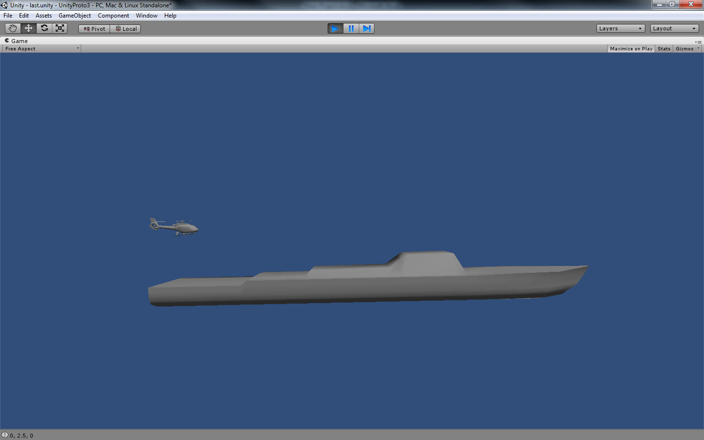

Figure 27. Image of ship prototype

When the model is ‘playing’ the application can produce coordinates for points on ship model as it virtualises movement in 3D space. It is proposed to harness these coordinates to provide a dataset for the movement of the landing pad relative to the ships poise.

Vector3 point = gameObject.transform.position;

print(point.x + ", " + point.y + ", " + point.z);

A sample of the data recorded for the motion of the model is shown below. This particular dataset only applies to the centre point of the model and so does not show responses to rotation, as the model rotates around it centre point. It is proposed to add a number of reference points to the model that can then be tracked.

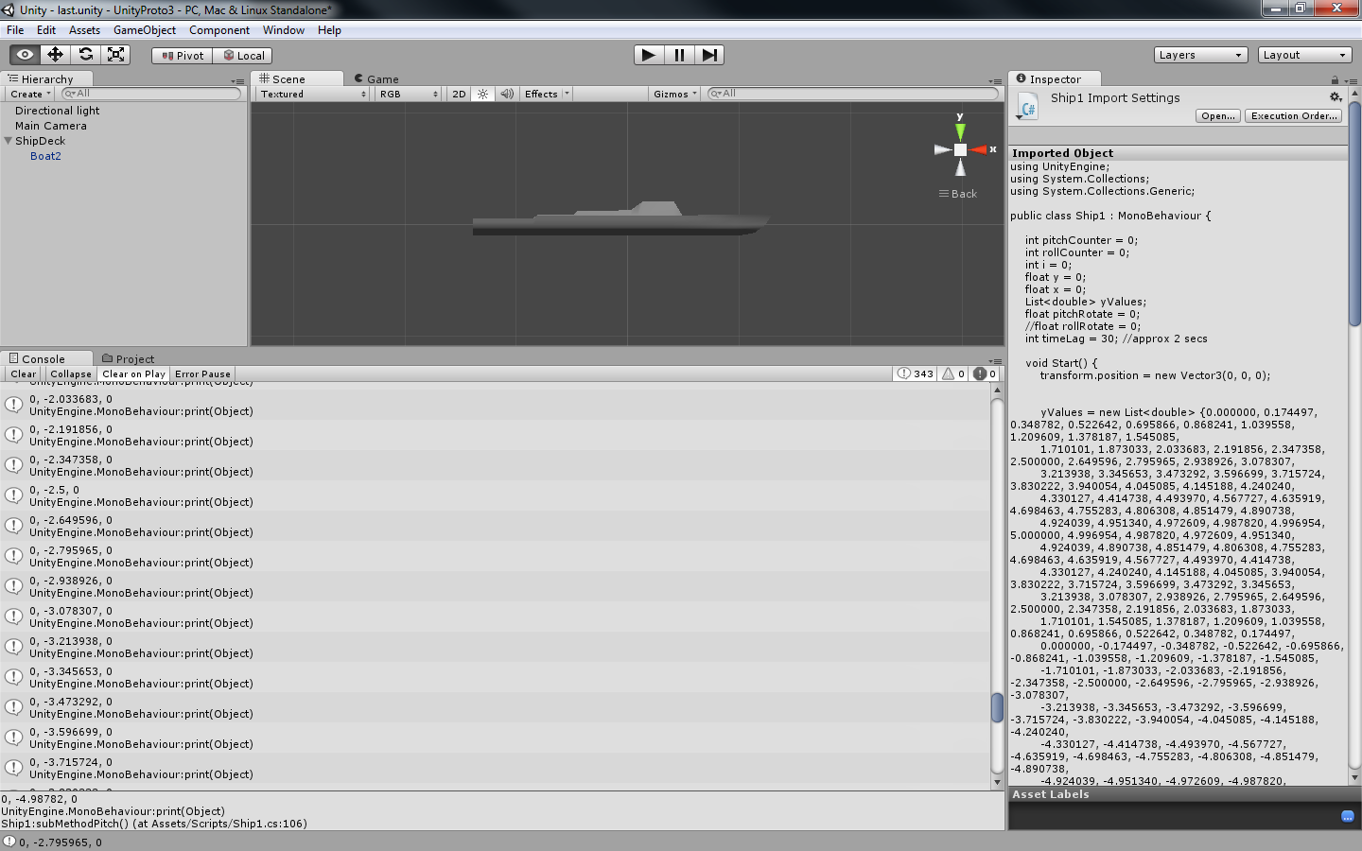

Figure 28. Code snippet of ship coordinates

A prototype was also created for the infra-red beacons on the ship as they would appear to a camera situated directly above the landing platform (see figure 29). The same script was run against this model and the poise of the landing platform was observed as the model moved in a virtual environment symbolic of sea state 6.

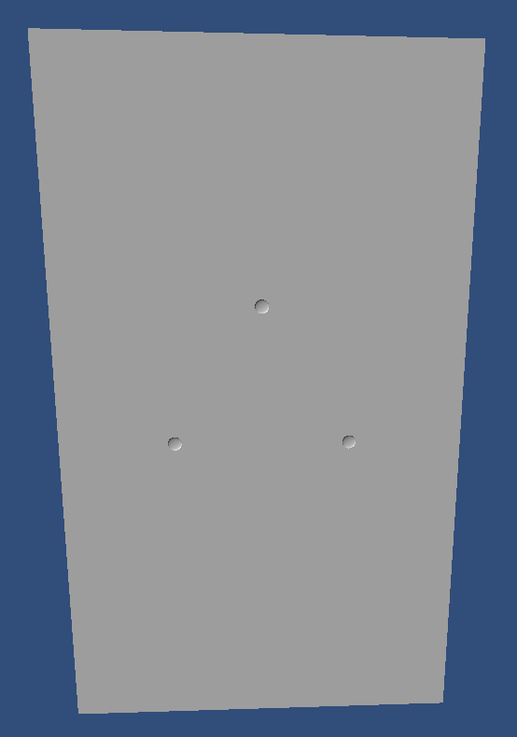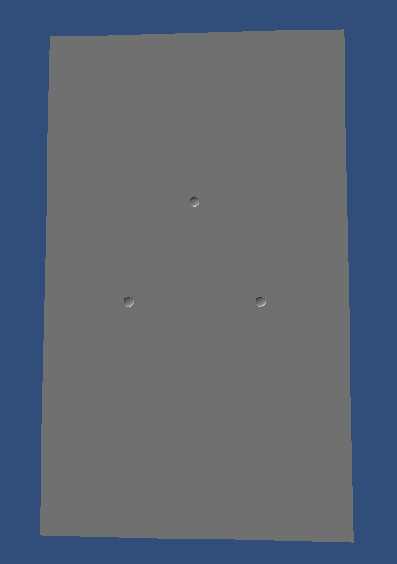

Figure 29. Images of landing pad prototype

# 7. Equations of Motion

## 7.1 Degrees of Freedom

If a body can move in any direction in space, it is said to have six degrees of freedom (6DoF). There are three possible translations in the x, y and z axes and also three possible rotations in a 3D space. Both aircraft and ocean going vessels have 6DoF as they operate in their respective environments. The buoyancy of the ship counteracts gravity as it sails on the ocean and the lift exerted by an aircraft allows it to stay airborne, neutralising gravity. Both vehicles exhibit motion in all three translational and rotational vectors.

## 7.2 Motion in 3D Space

A body in 3D space can be represented as a set of Cartesian coordinates such that

$${S=\{(x}_{1}{,y}_{1},z_{1})⋯{(x}_{n}{,y}_{n},z_{n})\}$$

where:

$x_{1}{,y}_{1},z_{1}$ = the x, y and z coordinate in a spatial plane, and

n = the number of points on the body.

This set of coordinates can also be represented as a set of 1 x 3 matrix or column vectors where n is the number of points on the body so that

$$S_{n}=\left\{\left[\begin{matrix}x_{1} \\ y_{1} \\ z_{1}\end{matrix}\right],\left[\begin{matrix}x_{2} \\ y_{2} \\ z_{2}\end{matrix}\right]⋯\left[\begin{matrix}x_{n} \\ y_{n} \\ z_{n}\end{matrix}\right]\right\}$$

When matrix computation is then used, it is possible to translate and rotate the coordinates of the body with relative ease using variations of the transformation matrix A. However, to aid in this computation a homogeneous coordinate system is used, such that;

$${S=\{(x}_{1}{,y}_{1},z_{1},1)⋯{(x}_{n}{,y}_{n},z_{n},1)\}$$

and

$$S_{n}=\left\{\left[\begin{matrix}x_{1} \\ y_{1} \\ \begin{matrix}z_{1} \\ 1\end{matrix}\end{matrix}\right],\left[\begin{matrix}x_{2} \\ y_{2} \\ \begin{matrix}z_{2} \\ 1\end{matrix}\end{matrix}\right]⋯\left[\begin{matrix}x_{n} \\ y_{n} \\ \begin{matrix}z_{n} \\ 1\end{matrix}\end{matrix}\right]\right\}$$

Translation of coordinate (x, y, z, 1) by scalar quantities a, b, c will result in new coordinates $\left(x^{'}, y^{'}, z^{'}, 1\right)$ when a translation homogeneous matrix is applied, such that;

$$A^{T}=\left[\begin{matrix}x' \\ y' \\ \begin{matrix}z' \\ 1\end{matrix}\end{matrix}\right]= \left[\begin{matrix}\begin{matrix}1 & 0 \\ 0 & 1\end{matrix} & \begin{matrix}0 & a \\ 0 & b\end{matrix} \\ \begin{matrix}0 & 0 \\ 0 & 0\end{matrix} & \begin{matrix}1 & c \\ 0 & 1\end{matrix}\end{matrix}\right]\left[\begin{matrix}x \\ y \\ \begin{matrix}z \\ 1\end{matrix}\end{matrix}\right]=\left[\begin{matrix}\begin{matrix}x+a \\ y+b\end{matrix} \\ \begin{matrix}z+c \\ 1\end{matrix}\end{matrix}\right]$$

Rotation of coordinate (x, y, z, 1) in the x axis by an angle $∅$ will result in new coordinates $\left(x^{'}, y^{'}, z^{'},1\right)$

$$A^{T}=\left[\begin{matrix}x' \\ y' \\ \begin{matrix}z' \\ 1\end{matrix}\end{matrix}\right]=\left[\begin{matrix}\begin{matrix}1 & 0 \\ 0 & \operatorname{Cos}{∅}\end{matrix} & \begin{matrix} 0 & 0 \\ -\operatorname{Sin}{∅} & 0\end{matrix} \\ \begin{matrix}0 & \operatorname{Sin}{∅} \\ 0 & 0\end{matrix} & \begin{matrix}\operatorname{Cos}{∅} & 0 \\ 0 & 1\end{matrix}\end{matrix}\right]\left[\begin{matrix}x \\ y \\ \begin{matrix}z \\ 1\end{matrix}\end{matrix}\right]=\left[\begin{matrix}\begin{matrix}x \\ yCos∅-z\operatorname{Sin}{∅}\end{matrix} \\ \begin{matrix}ySin∅+zCos∅ \\ 1\end{matrix}\end{matrix}\right]$$

Rotation of coordinate (x, y, z, 1) in the y axis by an angle $θ$ will result in new coordinates $\left(x^{'}, y^{'}, z^{'},1\right)$

$$A^{T}=\left[\begin{matrix}x' \\ y' \\ \begin{matrix}z' \\ 1\end{matrix}\end{matrix}\right]=\left[\begin{matrix}\begin{matrix}\operatorname{Cos}{θ} & 0 \\ 0 & 1\end{matrix} & \begin{matrix}\operatorname{Sin}{θ} & 0 \\ 0 & 0\end{matrix} \\ \begin{matrix}-\operatorname{Sin}{θ} & 0 \\ 0 & 0\end{matrix} & \begin{matrix}\operatorname{Cos}{θ} & 0 \\ 0 & 1\end{matrix}\end{matrix}\right]\left[\begin{matrix}x \\ y \\ \begin{matrix}z \\ 1\end{matrix}\end{matrix}\right]=\left[\begin{matrix}\begin{matrix}\operatorname{xCos}{θ}+\operatorname{zSin}{θ} \\ y\end{matrix} \\ \begin{matrix}-\operatorname{xSin}{θ+\operatorname{zCos}{θ}} \\ 1\end{matrix}\end{matrix}\right]$$

Rotation of coordinate (x, y, z, 1) in the z axis by an angle $φ$ will result in new coordinates $\left(x^{'}, y^{'}, z^{'},1\right)$

$$A^{T}=\left[\begin{matrix}x' \\ y' \\ \begin{matrix}z' \\ 1\end{matrix}\end{matrix}\right]=\left[\begin{matrix}\begin{matrix}\operatorname{Cos}{φ} & -\operatorname{Sin}{φ} \\ \operatorname{Sin}{φ} & \operatorname{Cos}{φ}\end{matrix} & \begin{matrix}0 & 0 \\ 0 & 0\end{matrix} \\ \begin{matrix}0 & 0 \\ 0 & 0\end{matrix} & \begin{matrix}1 & 0 \\ 0 & 1\end{matrix}\end{matrix}\right]\left[\begin{matrix}x \\ y \\ \begin{matrix}z \\ 1\end{matrix}\end{matrix}\right]=\left[\begin{matrix}\begin{matrix}\operatorname{xCos}{φ}-\operatorname{ySin}{φ} \\ \operatorname{xSin}{φ+}\operatorname{yCos}{φ}\end{matrix} \\ \begin{matrix}z \\ 1\end{matrix}\end{matrix}\right]$$

where

$∅=$ roll rotational angle

$θ=$ pitch rotational angle

$φ=$ yaw rotational angle

To calculate the respective angles of rotation, coordinate geometry will be utilised. This will involve comparing the actual location of the coordinates with the corresponding coordinates in the know pattern of infra-red beacons. From there, the rotations can be extrapolated using the Sine or Cosine rules depending on the information that is known at the time.

## 7.3 Summary

In the computational model proposed, it is expected to evaluate the coordinates of the ship based infra-red beacons and the coordinate of the UAV, using calculations which include the translations described above or variations and combinations of them.

The ship’s infra-red beacons will have coordinates in the ‘World Plane,’ whereas the camera is fixed to the UAV which will have its own ‘Object Plane’ (see figure 30). As it is proposed to simulate the camera output, the ship based coordinates will need to be mapped to the object plane, i.e. the UAV object plane.

UAV Object Plane

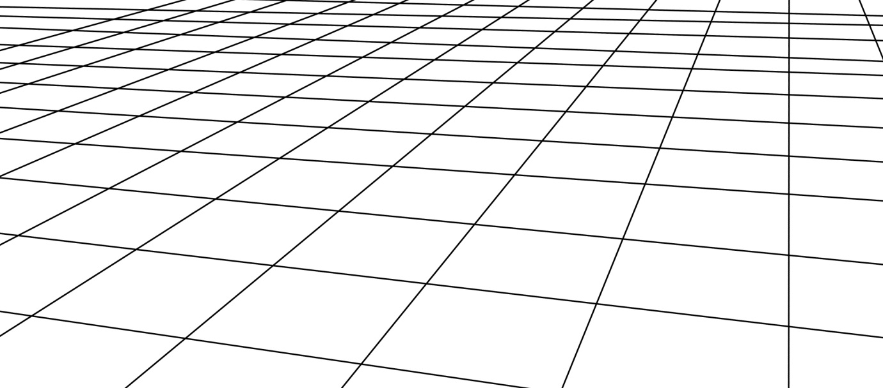

World Plane (x,y,z)

Figure 30. 3D Plane representation

# 8. Photogrammetry and Image Generation

## 8.1 Introduction

The essence of the project is to track infrared beacons on the deck of a ship and compute course corrections for an airborne VTOL UAV, based on the location and poise of those beacons relative to the UAV. As this is a simulation, the logic behind these course corrections uses a visual representation of the beacons, as they would appear in images taken with a camera fitted to the fuselage of a UAV. The camera’s images are processed and the target’s parameters are established. These parameters provide the flight control unit with a vector distance to the landing pad on the deck of the ship.

For this implementation, the image data is simulated by computing the coordinates of the beacons as they would appear on an image based on the relative poise of the two crafts at any given time. If the focal point and length of the camera, the Charge Coupled Device (CCD) size and resolution, the positions of the camera and the beacons in 3D space are known, then an image simulation can be generated. When all the camera’s characteristics are known, the VTOL UAV’s INS provides the camera’s location and the coordinates of the beacons on the deck of the ship are streamed to the UAV. Using this data and parameterizes equations for lines from the individual beacons to the focal point of the camera, the image of the beacons can be simulated. Figure 31 below shows a model that represents this process. Where $x_{1},y_{1}$  
 represents a beacon on the deck of the ship, $f$ is the focal point of the camera and $x_{2},y_{2}$ is the corresponding point on the camera’s CCD. Initially the z coordinate is not shown but is included later in the chapter.

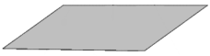

$$x_{2},y_{2}$$

•

Camera Model

CCD plane

$$f$$

•

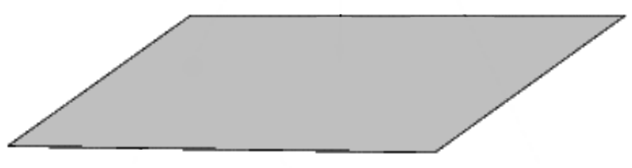

$$x_{1},y_{1}$$

•

Target plane

Figure 31. Simple Camera Model

To simplify the calculations when simulating the beacons locations as they would appear in the image, a virtual plane and the single focal point are considered. This virtual plane is positioned exactly the same distance from $f$, the focal point, as the CCD plane but on the target side of the focal point as shown in Figure 32. This arrangement of the virtual plane and focal point, provides a representation of the target as it would appear in an image provided by a camera, all things being equal. By moving the virtual plane in front of the focal point the image will not be inverted and by placing it at exactly the same distance from the focal point the coordinates of anything appearing on the CCD will have matching (but not inverted) coordinates on the virtual projection plane. In this example, a point $a_{t}$ on the target plane can be represented on the cameras CCD at point $a_{p}$ and on the virtual plane discussed earlier at point $a_{v}$ provide the distance between the focal point $f$ and the virtual plane i.e. $f_{{length}_{2}}$ equals $f_{{length}_{1}}$ the distance from the CCD to the focal point.

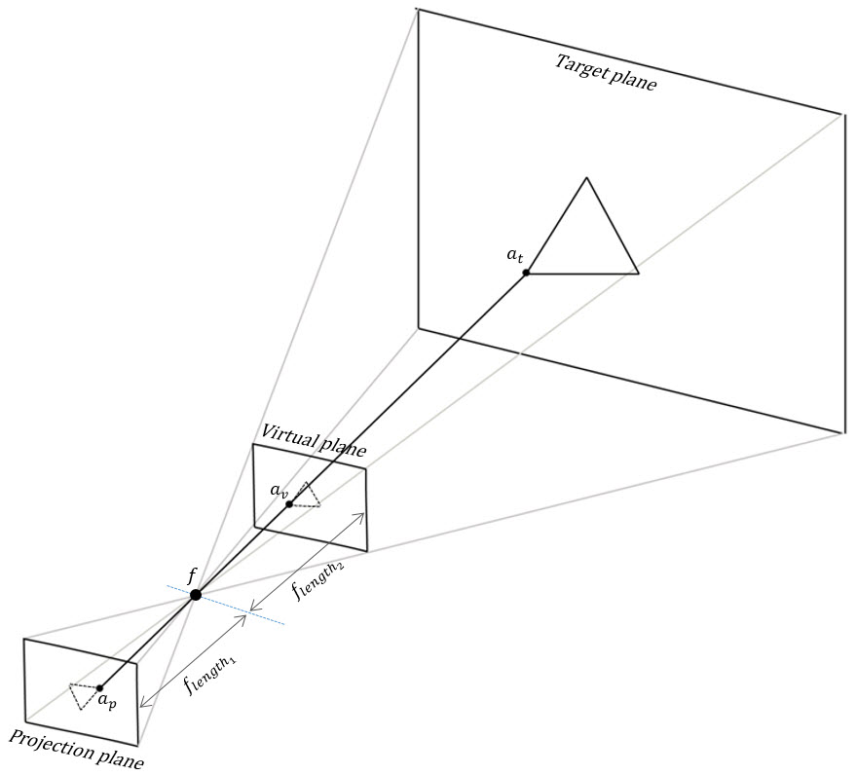

Figure 32. Project & Virtual Planes

## 8.2 Parameterized Equations

Coordinates on the virtual plane can now be represented mathematically by using parameterized equations. Considering Figure 33.

$$x_{2},y_{2},z_{2}$$

$$f$$

•

$$x\left(t\right),y\left(t\right), z(t)$$



Virtual Projection plane

•



$$p$$

$$x_{1},y_{1}, z_{1}$$

•

Target plane

Figure 33. Virtual Projection Plane in 3D space

Where $f$ is the focal point of a camera and has three dimensional coordinates $x_{2},y_{2},z_{2}$ and $p$ is a point on the target plane, e.g. one of the infrared beacons with coordinates $x_{1},y_{1},z_{1}$ then the coordinates of the point on the virtual plane where the line segment $\vec{p f}$ insects the virtual plane can be calculated if the focal length is known and the coordinates for $p$ and $f$ are known. This point $x\left(t\right),y\left(t\right), z(t)$ can be expressed with three equations;

$$x\left(t\right)= x_{1}+at$$

$$y\left(t\right)= y_{1}+bt$$

$$z\left(t\right)= z_{1}+ct$$

Where

$$a= x_{2}- x_{1}$$

$$b= y_{2}- y_{1}$$

$$c= z_{2}- z_{1}$$

These values $a,b \& c$ are the values for the components of the directional vector for the line segment $\vec{p f}$ and as shown above are equal to $\left(x_{2}- x_{1}, y_{2}- y_{1},{ z}_{2}- z_{1} \right)$.

In the model described above the value for $t$ can be calculated if the camera is set perpendicular to the $x-z$ plane. By taking this approach the value for $y\left(t\right)$ is known as it is $y_{2}$ less the focal length of the camera;

$$y\left(t\right)= y_{2}- f_{length}= y_{1}+bt$$

therefore

$$t= \frac{y_{2}- f_{length}- y_{1}}{y_{2}- y_{1}}$$

The value for $t$ can then be used to equate the coordinates on the virtual plane for $x\left(t\right), z(t)$

$$x\left(t\right)= x_{1}+a\frac{y_{2}- f_{length}- y_{1}}{y_{2}- y_{1}}$$

$$z\left(t\right)= z_{1}+c\frac{y_{2}- f_{length}- y_{1}}{y_{2}- y_{1}}$$

So, given two points, one on the target plane (infrared beacon) and the other the focal point of the camera and also knowing the details of the camera, it is possible to recreate an image as it would be produced by the camera.

## 8.3 Conclusion

This was the process that was used to create simulated images of the infrared beacons as they would appear on the deck of a ship, see Figure 34 below. $x\left(t\right), z(t)$ represent the image coordinates $x, y$. The camera was penpendicular to the world plane $x-z$ simply the required calculations. If the camera is not perpendicular then the $x-z$ plane and is in fact rotated then a translation or series of translations described in section 7.2 Motion in 3D Space would also need to be considered. A rotation translation would be performed on the two known points $p$ and $f$, it is only then that the parameterized equations could be used to give the coordinates.

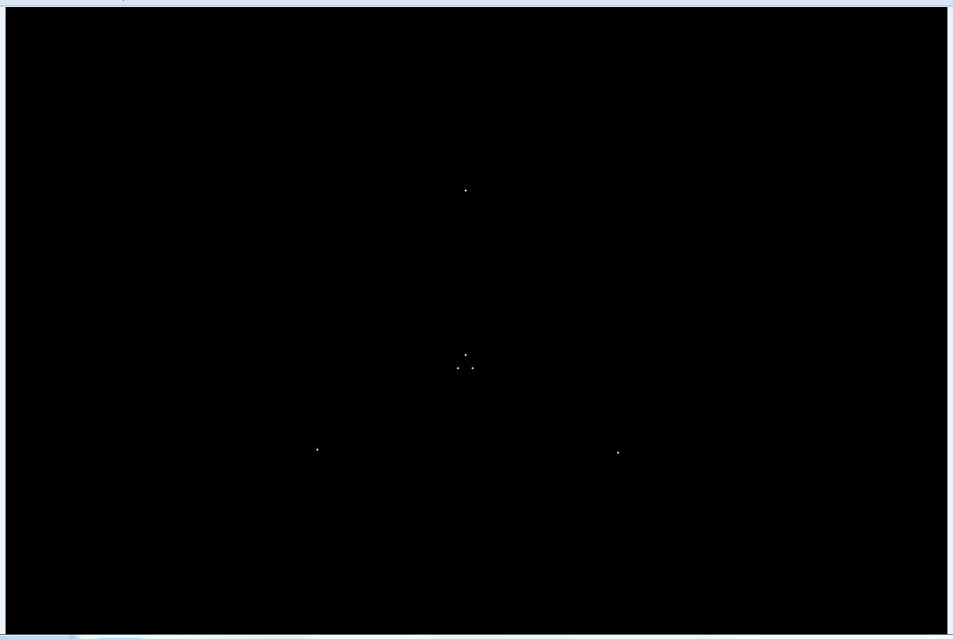

Figure 34. Simulated Image with beacons shown

# 9. Project Implementation – The Ship Model

## 9.1 Ship’s Motion Data

The initial framework for the structure of the waves and the ship responses to it was based on a sinusoidal wave. The data generated for these waves was added to a set of collections and the individual collections were then added to the parent collection _motionArray. The wave sampling was performed at 30Hz. The decision was made to concentrate on the three motions of a ship that display the greatest variation, these being pitch, roll, and heave. Although the thrust of the ship i.e. it’s surge is constantly under external forces to change from e.g. wind, waves and drag, the velocity and acceleration of the UAV is substantially greater than that of the ship and the overall relative effect is not as significant as the relative motions of pitch, roll and heave. For similar reasons the effects of sway and yaw are not included in the calculations for motion of the ship model. Sway being a lateral sideways motion and yaw a rotation in the axis pointing vertically up and down from the ship’s centre of buoyancy.

When generating the motion data for the ship model a particular vessel was considered. This vessel is the DDG-51 Arleigh Burke Class and is shown in Figure 35.

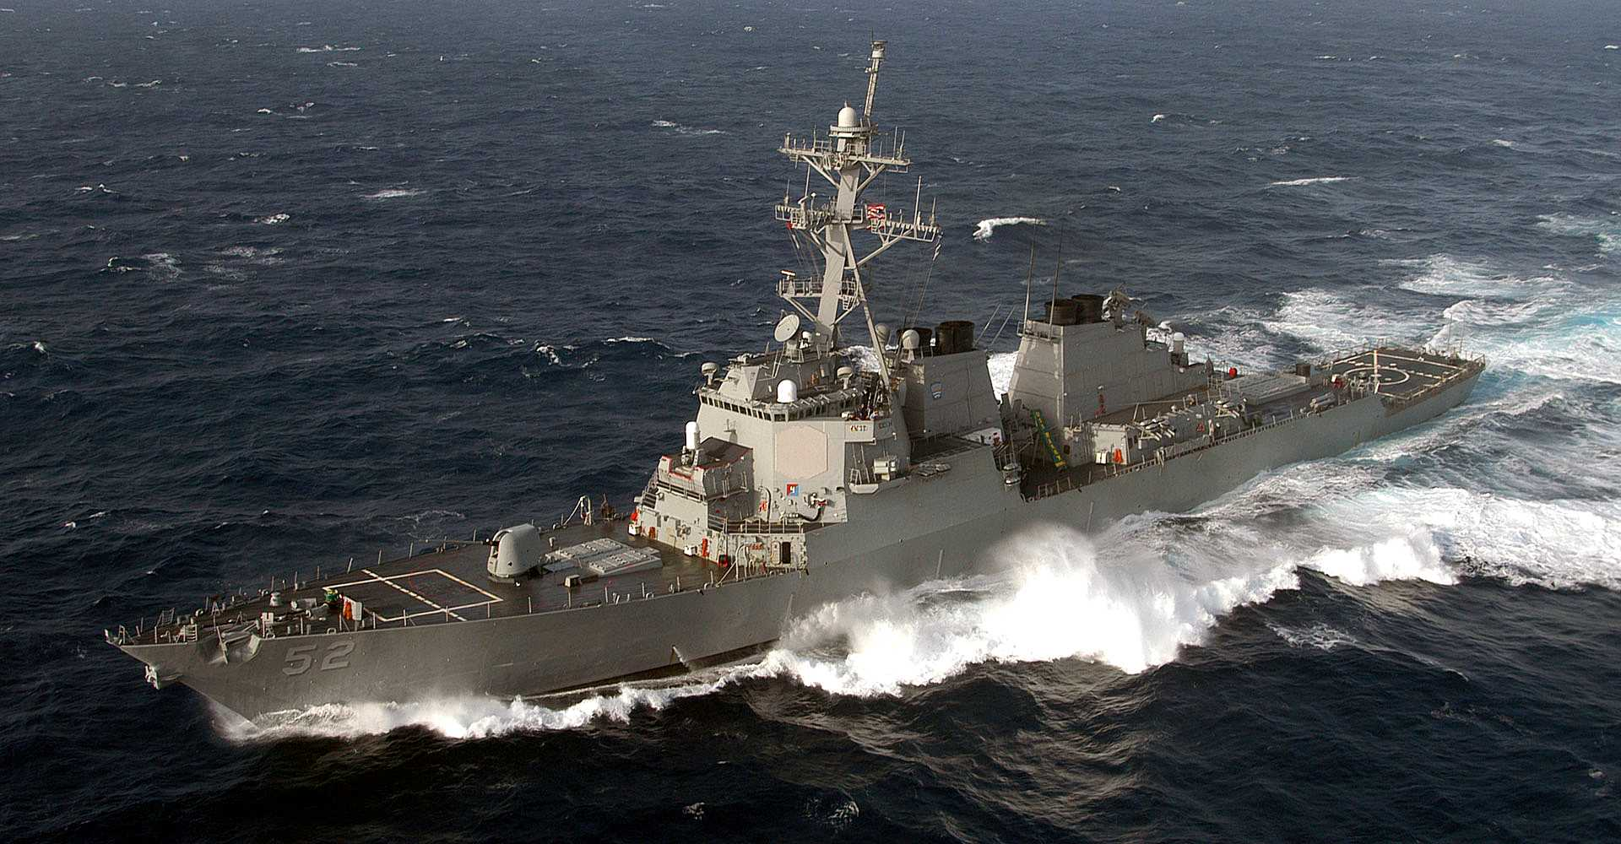

Figure 35. DDG-51 Arleigh Burke Class (Sakhal, 2014)

A number of the characteristics of the ship were referenced when the motion data was being generated.

|  |  |
| --- | --- |
| Item | Ship Details *at Sea State Six |
| Name | DDG-51 Arleigh Burke Class |
| Length | 142m |
| Beam | 18m |
| Top Speed* | 16.5 ms-1 |
| Maximum Roll Angle* | 16 degrees |
| Maximum Pitch Angle* | 6 degrees |

Figure 36. DDG-51 Arleigh Burke Class details (McDonald, 1993)

The data generated by the application is for the purposes of a test platform for the UAV application, and does not allow for the possibility of the vessel’s length being greater than the wave length of a wave system. When this happens there would be an averaging affect relative to the buoyancy of the ship, any moments about the ships centre of buoyancy in effect at the time.

## 9.2 The ship model in Unity

The image below in Figure 37 shows the ship model in Unity. A simulated landing pad was added to the back of the ship with a ‘Box Collider’ and a ‘Rigid Body’ property applied see Figure 38.

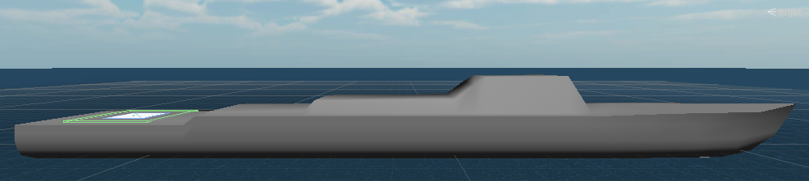

Figure 37. Ship model in Unity

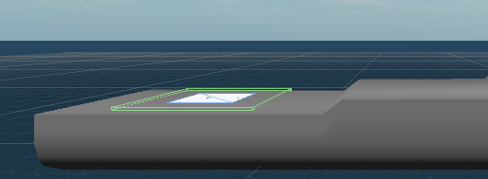

Figure 38. Landing pad with box collider applied

When the corresponding box collider on the fuselage of the UVA contacts the ship box collider on the landing pad, the collision is detected and the desired action can be taken. In this case a ‘flag’ array of bytes is posted to the other pc to stop processing and shut down the UDP connection. The rigid body properties applied to both craft prevents them from passing through each other, as such, acting like real world material. The model setup in the Unity inspector window is show in Figure 39 below.

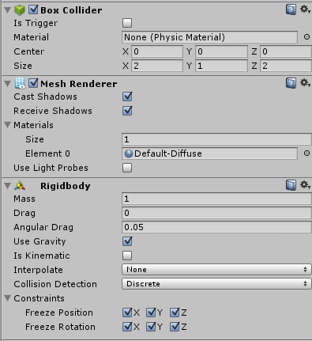

Figure 39. Unity Inspector Settings for the ship model

# 10. Project Implementation – The UAV Model

As stated earlier, a third party model of the UAV was obtained from an asset website, (TF3DM, 2013) and then added to the projects folder in Unity, see Figures 40 & 41 below. To facilitate visual inspection of the two models in one presentation as they interact with each other, the UAV has been scaled in this simulation. The Unity ‘behaviour’ script was then added to this game object. The UAV behaviour script actively listens for new coordinates as the application is running. These coordinates are received from the UdpConnection and UAVCoordinates class which has an asynchronous receive method. Each time a new set of coordinates is received an adjustment is made to the UAV model.

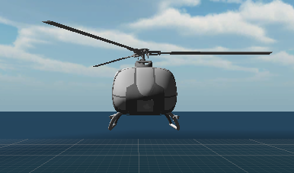

Figure 40. UAV model front view

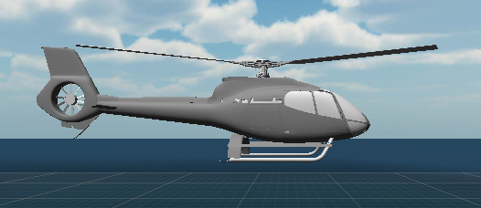

Figure 41. UAV model side view

Like the ship model a box collider as applied to the UAV and is the approximate size of the helicopter skids see Figure 42 below.

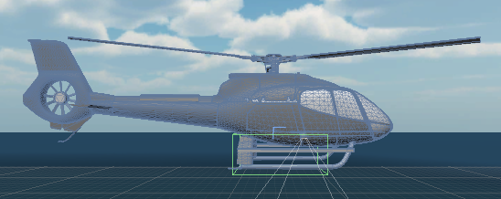

Figure 42. UAV model showing box collider

# 11. Implementation – Class Diagrams

## 11.1 Ship Implementation

### 11.1.1 Presentation Layer



Figure 43. Ship - Presentation Layer Class Diagram

### 11.1.2 Control Layer



Figure 44. Ship - Control Layer Class Diagram

11.1.3 Business Layer



Figure 45. Ship - Business Layer Class Diagram

11.1.4 Service Layer



Figure 46. Ship - Service Layer Class Diagram

## 11.2 UAV Implementation

11.2.1 Presentation Layer



Figure 47. UAV - Presentation Layer Class Diagram

11.2.2 Control Layer



Figure 48. Control Layer Class Diagram

### 11.2.3 Business Layer

#### 11.2.3.1 Camera Simulator



Figure 49. UAV - Business Layer, Camera Simulator Class Diagram

#### 11.2.3.2 Flight Simulator



Figure 50 UAV - Business Layer, Flight Simulator Class Diagram

#### 11.2.3.3 INS Simulator



Figure 51 UAV - Business Layer, INS Simulator Class Diagram

#### 11.2.3.4 Image Processor



Figure 52. Uav - Business Layer, Image Processor Class Diagram

11.2.3.5 Navigation Unit



Figure 53. UAV - Business Layer, Navigation Unit Class Diagram

11.2.4 Service Layer



Figure 54. UAV - Business Layer, Service Layer Class Diagram

# 12. Implementation – Flowcharts

## 12.1 Ship Implementation Flowchart



Figure 55. Ship Implementation Flow Chart

## 12.2 UAV Implementation Flowchart



Figure 56. UAV Implementation Flow Chart

## 12.3 UAV Control Unit Flowchart



Figure 57. Control Unit Flow Chart

# 13. The Simulation Process

## 13.1 System Setup

This landing simulation was developed on two laptops connected via a cross over network cable. One laptop runs the Unity application to generate the coordinates of a set of simulated beacons on the deck of the ship. These coordinates are posted to the other laptop running the UAV UI application generated in Visual Studio (Microsoft, 2014). This second application processes the coordinates and generates a new set of coordinates for alterations to the UAV model’s position (on the first laptop). A visual of the data flow is shown below in Figure 58.

Control Unit

Simulation

Unity Presentation Layer

UAV UI Presentation Layer

Generate Ship Coordinates

Apply UAV Coordinates

Generate UAV Coordinates

Process Ship Coordinates

Send Ship Coordinates

Receive UAV Coordinates

Send UAV Coordinates

Receive Ship Coordinates

Network Cable

UDP Sockets

UDP Sockets

Figure 58. System Setup Overview

To achieve this functionality, the system establishes and maintains four separate threads. They are the startImageGeneration, startprocessImages, startNavigation and startPropulsion threads and are located in the Control Layer on PC 2.These threads mimic some of the functionality that would be expected as part of the flight system of an autonomous VTOL UAV. To facilitate the passing of data between these threads, the system uses three singletons which have double check locking to ensure the integrity of the information, and that data cannot be read by one thread while being updated by another. This was an important issue as the data is being updated and read at approximately 30Hz. The propulsion thread simulates the flight controls, reading required changes and posting the desired changes to PC 1 to move the model in the Unity application.

## 13.2 PC 1 – Presentation Layer

The classes in the presentation layer on PC 1 are responsible for displaying the two models information, which is generated in other layers and providing the user with a visual representation of the simulation. There are two main classes; ShipBehaviuorScript and UavBehaviourScript. There is one other small class responsible for detecting the landing ‘collision’, CollisionScript. All three classes implement the MonoBehaviour interface which is required by the Unity application. The two main classes have two standard methods, Start() and FixedUpdate() which are standard for Unity classes. The Start() method is executed once when the class is first instantiated. The FixedUpdate() method (which is a variance of the normal Update() method runs continuously. This method modifies the assets in the Unity display window during operation. The advantage of the FixedUpdate() method over the Update() method is the ability to set the refresh rate of the screen i.e. the rate at which the update method is run. Here it is set to 0.0333 which computes to approximately 30 frames per second. This is a best effort value and the load on the processor could impact this.

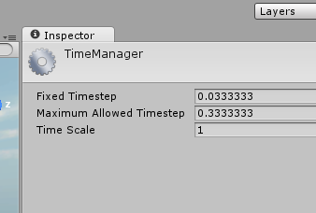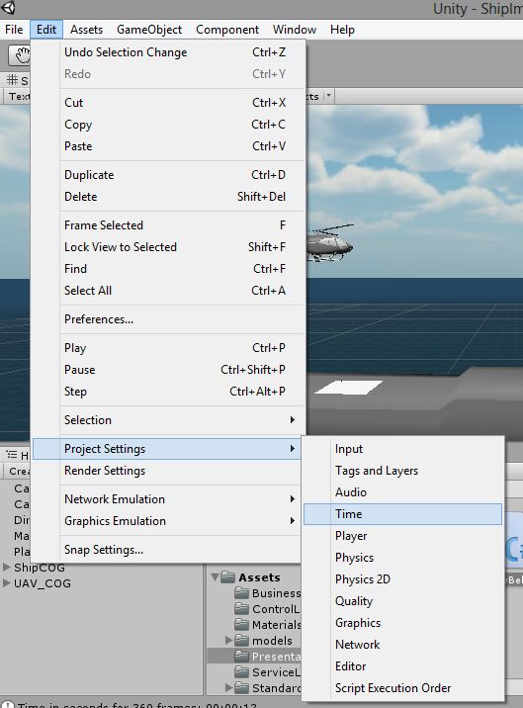

Figure 59. FixedUpdate() Setup

The FixedUpdate() method in the ship script is responsible for animating the ship model with the coordinates generated in the application’s business layer, and then calls the RecordCoordinates() method to establish the coordinates of the six beacons on the landing pad and forwards them to the control layer.

void FixedUpdate()

{

_modCount = _count % _heaveArray.Count;

gameObject.transform.Translate(0, _heaveArray[_modCount] * Time.deltaTime, 0,Space.World);

transform.eulerAngles = new Vector3(-_pitchArray[_modCount], 0, -_rollArray[_modCount]);

_count++;

RecordCoordinates();

}

The gameObject.transform.translate and transform.eulerAngles methods shown above are responsible for the animation of the ship mentioned above. This configuration initially proved challenging within Unity’s Mono Develop environment. When applying the various alterations to the ships poise there was unexpected results, depending on the transform function implemented.

Example 1 gameObject.transform.position = new Vector3(0, heaveArray[modCount], 0);

Example 2 Transform myTransform = transform;

myTransform.position = gameObject.transform.position + (Quaternion.Euler(0, heaveArray[modCount], 0) * new Vector3(0, 0, 0));

Example 3 myTransform.position = gameObject.transform.position + (Quaternion.Euler(0, 0, 0) * new Vector3(0, heaveArray[modCount], 0));

Example 4 gameObject.transform.position = new Vector3(0, heaveArray[modCount], 40);

Each of these setups worked as expected until they were combined with the transform operations for the pitch and roll rotations. There was also a number of ways this could be approached e.g.

Example 5 gameObject.transform.Rotate(new Vector3(pitchArray[modCount], 0, 0));

Example 6 gameObject.transform.Rotate(-pitchArray[modCount], 0, 0, Space.World);

Example 7 gameObject.transform.eulerAngles = new Vector3(pitchArray[modCount], 0, 0);

Some of the errors that were observed included rotation from the wrong pivot point, single direction motion i.e. the ship model would flip over, erratic motion and the model freezing. During this development period the same set of tested data was used to check the responses of a configuration.

## 13.3 PC 1 – Generating the Ship Coordinates

The data for the waves is obtained by sampling a set of six waves at 30Hz each. These waves have random amplitudes, relative frequency and wavelength within the expected ranges for Sea State Six. Other considerations are the ship’s speed and the direction of the waves relative to the ship. A decision was also made to supply datasets for the motions of the Arleigh Burke in Sea State Three and Zero. The ship’s speed, direction relative to the wave direction and the sea state are selections available each time the application is run.

When the process begins, a strategy pattern is introduced and the algorithm, specific to the sea state selected, is implemented. First the heave array is populated.

private void PopulateHeaveArray()

{

if (_currentSeaState != SeaState.SeaState0)

{

for (int i = 0; i < NumberOfWaves; i++)

{

var samples = (int)(_stateStrategy.Wavelength * _relativeWavelengthFactor

/ _relativeSpeed * WaveSampleFactor);

for (int j = 0; j < samples; j++)

{

_heaveValue = _stateStrategy.WaveHeight * (float)Math.Sin(2 * Math.PI * j / samples);

_heaveArray.Add(_heaveValue);

}

_samplesPerWaveList.Add(samples);

_stateStrategy.NewWaveStatistics();

}

}

else

{

_heaveArray.Add(_stateStrategy.WaveHeight);

}

}

With reference to the code above, initially a check is performed for Sea State Zero in which case there is no heave motion. Next, the outer ‘for’ loop sets the number of iterations of the inner algorithms to the number of waves in a set. Then the number of samples required to provide an approximation of 30 fps is computed. This value is dependent on the relative speed of the ship to the waves, the wavelength range expected for the selected sea state and the direction of the waves.

The inner for loop above calculates the heave displacements for the ship using the randomly generated wave amplitude and the equation for a Sine Wave

$$y\left(t\right)=Asin(2πft+ φ)$$

Where:

$y\left(t\right)$ is the corresponding y coordinate for a given time displacement

*A* is the amplitude of the wave,

$f$ is the frequency of the wave,

$t$ is a given time period, and

$φ$ is a phase factor, which is only required to shift the phase of the wave and is not used in the heave algorithm.

Then the number of samples for an individual wave is recorded as this will be required to process the pitch and roll collection and ensure that the three collections are in sync with one another. This is followed by a call to the method that generates a new wave for the next iteration. The PopulateHeaveArray() method terminates with a corresponding ‘else’ statement for the original ‘if’ statement and adds the zero wave height to the collection if the user has selected Sea State Zero when starting the application, this ensure synchronization through the processes.

Similar operations are then performed to compute the data for the pitch collection and the roll collection, the main difference being the parameters that are used in the calculations. As stated above the number of samples per wave is used when populating these collections ensuring synchronization. The three collections are added to the parent _motionArray and passed back to the Control Layer which in turn passes the coordinates for the ship model back to the presentation layer.

These three datasets are applied to a one metre cube at the approximate centre of the ship model. As the alterations are applied to the cube, the ship model responses proportionally as it is a child object of the one metre cube, even though it is substantially bigger.

## 13.4 PC 1 – Send Ship Coordinates

Part of the essential framework of this project implementation includes two UDP channels between the two applications, one in each direction. The decision was made to use UDP because of the reduced overhead associated with UDP packets when compared with IP/TCP communication, Internet Protocol – Transmission Control Protocol. Part of the reason for this speed difference is due to the lack of error checking performed by UDP; this however is acceptable in the proposed model as each new set of data posted to the recipient is complete and independent of the previous or next sets of data. The PostShipCoordinates() method shown below is responsible for sending the coordinates of the infrared beacons to the UAV application. The length of the byte array is set to 4 times the length of the float array as a float is 4 bytes long. The IP end point is also included in the SendTo() method for the server socket.

public void PostShipCoordinates(float [] coordinates)

{

try

{

_byteArray = new byte[coordinates.Length * BytesPerFloat];

Buffer.BlockCopy(coordinates, 0, _byteArray, 0, _byteArray.Length);

_server.SendTo(_byteArray, _byteArray.Length, SocketFlags.None, _ipep);

}

catch (Exception ex)

{

Console.WriteLine(ex.Message);

}

}

## 13.5 PC 1 – Receive UAV Coordinates

As a receive method is normally a blocking method, an asynchronous UDP socket is used to receive the data from the UAV application for the course corrections needed to update the UAV model in Unity. This asynchronous connection remains operating while the UAV in is flight and converts the byte stream to an array of floats which is then recorded and a NotifyPropertyChanged Method informs the Presentation Layer of the change and the model is updated accordingly. A number of different configurations for the receive method where initially tried before the asynchronous method, shown below, was successfully implemented. This configuration was sourced on the internet and altered to meet the needs of the project. This code can be seen at (Seo, 2013).

public void Starter()

{

#region Third Party Code - Altered to suit application (See below)

_udpSocket = new Socket(AddressFamily.InterNetwork, SocketType.Dgram, ProtocolType.Udp);

_udpSocket.Bind(new IPEndPoint(IPAddress.Any, 9050));

_buffer = new byte[1024];

EndPoint newClientEndPoint = new IPEndPoint(IPAddress.Any, 0);

_udpSocket.BeginReceiveFrom(_buffer, 0, _buffer.Length, SocketFlags.None,

ref newClientEndPoint, DoReceiveFrom, _udpSocket);

#endregion

}

private void DoReceiveFrom(IAsyncResult asynResultr)

{

#region Third Party Code - Altered to suit application

// Some of the code (next 7 lines and the code in the constructor) for this socket

// configuration was taken from:

// acrocontext.wordpress.com/2013/08/15/c-simple-udp-listener-in-asynchronous-way/

// and altered to suit the project requirements.

var receiveSocket = (Socket)asynResultr.AsyncState;

EndPoint clientEndPoint = new IPEndPoint(IPAddress.Any, 0);

int datagramLength = receiveSocket.EndReceiveFrom(asynResultr, ref clientEndPoint);

var data = new byte[datagramLength];

Array.Copy(_buffer, data, datagramLength);

EndPoint newClientEndPoint = new IPEndPoint(IPAddress.Any, 0);

_udpSocket.BeginReceiveFrom(_buffer, 0, _buffer.Length, SocketFlags.None,

ref newClientEndPoint, DoReceiveFrom, _udpSocket);

#endregion

_floatArray = new float[data.Length / sizeof(float)];

int index = 0;

for (int i = 0; i < _floatArray.Length; i++)

{

_floatArray[i] = BitConverter.ToSingle(data, index);

index += sizeof(float);

}

UavCoordinates = _floatArray;

}

Once this code was implemented there were no further issues with the UDP connection on both sides of the system.

## 13.6 PC 1 – Processing the UAV Coordinates

There is very little processing of the received coordinates for the UAV beyond passing them to the transform methods in the FixedUpdate() method. After the helicopter has landed however a new set of coordinates need to be applied to the UAV so it then matches the motion of the ship. This is achieved by finding the coordinates of the landing pad centre of gravity (COG) and applying it to the COG of the UAV model, allowing for a vertical difference between the two COGs.

void FixedUpdate()

{

if (!IsLanded == true)

{

gameObject.transform.position = new Vector3(xCoord, yCoord, zCoord);

gameObject.transform.eulerAngles = new Vector3(0, yRotation, 0);

}

else

{

xCoord = GameObject.Find("LandingPad").transform.position.x;

yCoord = GameObject.Find("LandingPad").transform.position.y + 3.0f; // adjustment for the vertical difference between the two Asset centres

zCoord = GameObject.Find("LandingPad").transform.position.z;

xRotation = GameObject.Find("LandingPad").transform.rotation.x;

yRotation = GameObject.Find("LandingPad").transform.rotation.y;

zRotation = GameObject.Find("LandingPad").transform.rotation.z;

if (_isFirstPass)

{

xRotationPrevious = xRotation;

yRotationPrevious = yRotation;

zRotationPrevious = zRotation;

gameObject.transform.position = new Vector3(xCoord, yCoord, zCoord);

transform.eulerAngles = new Vector3(xRotation, yRotation, zRotation);

_isFirstPass = false;

}

else

{

xRotation = xRotation - xRotationPrevious;

yRotation = yRotation - yRotationPrevious;

zRotation = zRotation - zRotationPrevious;

xRotationPrevious = xRotation;

yRotationPrevious = yRotation;

zRotationPrevious = zRotation;

gameObject.transform.position = new Vector3(xCoord, yCoord, zCoord);

transform.eulerAngles = new Vector3(xRotation, yRotation, zRotation);

}

}

## 13.7 PC 2 – Presentation Layer

On the second PC a Visual Studio application was developed. This included the user interface shown below in Figure 60. The user has the option to configure the application with the camera setup and decent rates.

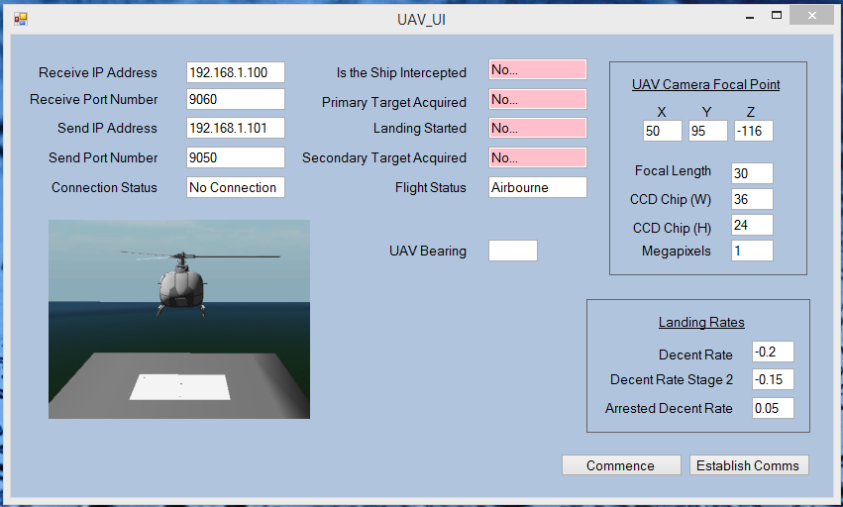

Figure 60. UAV User Interface

The UAV_UI class retrieves the data from the various text fields and passes the data to the UAVController class. Also at this stage listeners are registered with the two singletons that contain the data required by the UI. This data is retrieved automatically by property changed methods.

## 13.8 PC 2 – Receive Ship Coordinates

The same configuration for the UDP receive socket that was used in the ship implementation is also used for the UAV receive method, with the exception of additions to process the flag of bytes sent after the landing has been detected and the subsequent shut down of the socket.

## 13.9 PC 2 – Processing the Ship Coordinates

This system is a simulation to detect infrared beacons on the deck of a ship. Those beacons would normally appear as white shapes on an otherwise black image. In a real world system a camera would feed images or a video stream to an image processor. To simulate this, the class that generates the images adds white dots to a black background. There is no allowance for any other random or known infrared sources as would be the case in a real world application. These would need to be stripped out of any real image before the beacons could be found. Also in a real world image the representation of a beacon would appear as a blob of pixels rather than a single dot as is the case with this simulation. If real world images where to be used then a skeletisation process or similar would need to be performed on the blobs of pixels to find the centre of each beacon. For this simulation the camera is pointing vertically downward and no computations are included for a pivoting or rotating camera as may be the case in a sophisticated system.

When the ship coordinates are received by the second PC, the system generates images based on the location of the ship and the UAV. If they are not in range a full black image is processed as would be the case in the real world. When the images are within the field of view of the camera they are included in the image based on the known the known distance between the beacons and their coordinates and the coordinates of the UAV. Also if the UAV rotates then the image needs to rotate relative to the motion.

Given two points P and Q with coordinates (x,y,z) and (a,b,c) respectively the parametric equation of the line segment from P to Q is given as

x(t) = x + (a - x)t equation 1

y(t) = y + (b - y)t equation 2

z(t) = z + (c - z)t equation 3

The projection plane is to be set at a distance equal to the focal length in front of the focal point and parallel to the x-z plane. This will give the resultant image the same aspect as the point in the world plane (i.e. it will not be inverted).This setup will ensure that the y coordinate in the image will always be the same and can then be dropped from the image. In this case, x in the world plane will represent y in the image plane and z in the world plane will represent x in the image plane.

If Q is taken as the focal point of the camera then the x and z coordinates of a point in the field of view, as they would appear in the image can be calculated.

Taking f as the focal length and the 3D coordinates of the focal point (UAV) and the point (beacon) it is the possible to calculate the image coordinates;

y(t) = b - f, then taking equation 2

b - f = y + (b - y)t, therefore

t = (b - f - y) / (b - y) equation 4

Using the value for t in equation 4 and entering it into equations 1 & 3, x(t) and z(t) can now be calculated for the image coordinates of the ray trace as it insects the projection plane from a given point in space.

For any given point the following method calculates the t value discussed earlier.

private double CalculateParameterT(double focalyValue, double pointyCoord)

{

_t = (focalyValue - _focalLengthmetres - pointyCoord) / (focalyValue - pointyCoord);

return _t;

}

The image coordinates are then calculated irrespective of whether they would actually appear in the image or not, this is handled later. As per equation one and three

private double CalculateImageCoordinate(double pointCoordinate, double cameraCoordinate, double t)

{

_coordinate = pointCoordinate + ((cameraCoordinate - pointCoordinate) * t);

return _coordinate;

}

Next the coordinates are mapped to their pixel equivalent. This involves three steps, map the pixels regardless of whether or not they would be in the final image. Any rotation of the image due to the UAV rotation at that time is then computed. And finally if the pixel coordinates fall with the bounds of the image they are added.

_dx = (coordinateXMetres - _currentUavFocalPointCoordinates[0]) * ConvertMetreToMm * _pixelPerMm;

_dy = (coordinateZMetres - _currentUavFocalPointCoordinates[2]) * ConvertMetreToMm * _pixelPerMm;

_point.X = SafeDoubleToInt(_dx) + (_halfWidthInPixels);

_point.Y = SafeDoubleToInt(-_dy) + (_halfHeightInPixels); // coordinate to pixel conversion

if (_point.X >= -_widthInPixels && _point.X < (_widthInPixels * 2) &&

_point.Y >= -_heightInPixels && _point.Y < (_heightInPixels * 2))

{

_point = TranslatePointsForRelativeRotation(_point);

}

if (_point.X >= 0 && _point.X < _widthInPixels && _point.Y >= 0 && _point.Y < _heightInPixels)

{

_listOfPositiveImagePixels.Add(_point);

}

The TranslatePointsForRelativeRotation() method above uses the a 2D rotation matrix similar to the 3D matrices described in section 7.2 Motion in 3D Space. To perform this operation the rotation point need to be translated to the origin, then

$$\left[\begin{matrix}x^{1} \\ y^{1}\end{matrix}\right]= \left[\begin{matrix}cosθ & -sinθ \\ sinθ & cosθ\end{matrix}\right]\left[\begin{matrix}x \\ y\end{matrix}\right]$$

Which then multiples out to two equations, one for the new x coordinate and another for the new y coordinate and the desired rotation of θ in radians, so that;

$$x^{1}=xcosθ-ysinθ$$

$$y^{1}=xsinθ+ycosθ$$

The code below includes the equation above and also both the translation to the origin and then the retranslation to find the point required.

if (_relativeBearing != 0)

{

// Convert image Y values

point.Y = point.Y * -1;

_imageCentre.Y = _imageCentre.Y * -1;

double bearingInRadians = (double)_relativeBearing * (Math.PI / 180);

double cosAngle = Math.Cos(bearingInRadians);

double sinAngle = Math.Sin(bearingInRadians);

newPoint.X = SafeDoubleToInt(cosAngle * (point.X - _imageCentre.X) - sinAngle * (point.Y - _imageCentre.Y) + _imageCentre.X);

newPoint.Y = SafeDoubleToInt(sinAngle * (point.X - _imageCentre.X) + cosAngle * (point.Y - _imageCentre.Y) + _imageCentre.Y);

// Convert y value back to image coordinates

_imageCentre.Y = _imageCentre.Y * -1;

newPoint.Y = newPoint.Y * -1;

}

When deciding whether to rotate potential coordinates or not, a range between –imageWidth to imageWidth*2 and a similar for the height of the image is taken. This is to ensure that there are no pixels lost on a diagonal from the centre. As the two bodies are moving independent to each other, the system is trying to replicate the images it seemed prudent to expand the acceptable range, which is then further filtered down to match the actual image size after the rotation.

Following the generation of the images the next process was to then read the images and record the coordinates if any, contained in the image. To achieve this C pointers were used to scan the images.

var bmData2 = CurrentImage.LockBits(new Rectangle(0, 0, CurrentImage.Width, CurrentImage.Height), ImageLockMode.ReadWrite, PixelFormat.Format8bppIndexed);

var stride = bmData2.Stride;

System.IntPtr scan1 = bmData2.Scan0;

unsafe

{

byte* pointer = (byte*)(void*)scan1;

for (int y = 0; y < CurrentImage.Height; ++y)

{

for (int x = 0; x < CurrentImage.Width; ++x)

{

if (pointer[0] > _pixelValue)

{

_currentPoint.X = x;

_currentPoint.Y = y;

}

pointer++;

}

}

}

CurrentImage.UnlockBits(bmData2);

However the performance of this code proved unsatisfactory. The times required to scan the images where very poor and there was also intermittent errors, see Figure 61 below. It is believed that the root of the issue lies in the way the central processing unit (CPU) processes images, and particularly when the memory location for the image is locked, as the code above does. The CPU was generating and saving images while try to read the images in a separate process. It is possible to process an image with the graphics processing unit (GPU) using a software development kit (SDK) like OpenCL(AMD, 2014) however this functionality was not supported by the PC used for this project. In a real world application, the generation of the images and the processing of those images would normally be carried out on different systems i.e. a camera / video camera and an image processor.

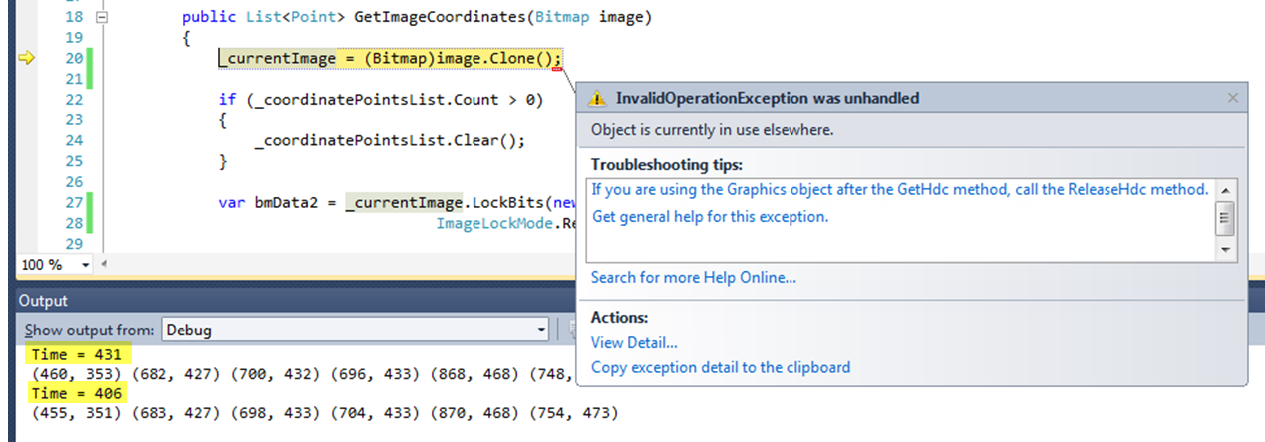

Figure 61. Image Processing Error and Unsatisfactory Times (ms)

As an alternative, the image pixel coordinates for the beacons as they would appear in a generated image, where passed on to the other processes thus removing the image processing from the workflow of the system.

## 13.10 PC 2 – Generating the UAV Coordinates

This is a substantial part of the system and includes the main set of algorithms used to computer the alterations needed to the flight of the UAV. Initially the required data is pulled from the system singletons. This includes the current coordinates of the UAV, the current set of ship coordinates, the current list of image coordinates, the bearing of the ship and UAV and the current flight status of the UAV.

For each iteration of the algorithms, the control unit decides which sub-process to call. This decision is based on the current flight status and the number of points in the list of image coordinates. When the UAV is not over the target there are not coordinates to process. This lack of input data is interpreted by the control unit as a need to intercept the ship. The first operation is to determine the intercept angle for the ship; this is performed by the Rotate class.

public static int GetRotationAngle(int[] uavXZ, int[] shipXZ)

{

_uavXZCoordinate = uavXZ;

_shipXZCoordinate = shipXZ;

int dx = _shipXZCoordinate[0] - _uavXZCoordinate[0];

int dy = _shipXZCoordinate[1] - _uavXZCoordinate[1];

// Raw bearing between 2 points

int angle = SafeDoubleToInt(Math.Atan2(dy, dx) * (180 / Math.PI));

// Remove minus sign

if (angle < 0)

{

angle = angle + 360;

}

// Need to allow for current bearing

angle = InsSimulationSingleton.GetInstance().UavBearing - angle;

return angle;

}

When the difference in the x and y’s of the two points are processed by the arctan function, the result is the angle between to two points in radians. This is converted to degrees and the current bearing of the UAV is subtracted. The result is the required bearing alteration to intercept the ship. Next the control unit alters the intercept flight height and the UAV flies to intercept the ship. All the alterations required to the UAV’s flight are incremental in the workflow which keeps iterating until the current requirement is achieved.

When the control unit detects the beacon coordinates it interprets this, as the ship has been intercepted, there is some further adjustment to ensure the UAV is over the centre of the ship. The Rotate class is used again to determine the bearing adjustment required to match the ship’s bearing. Once the UAV is directly over the centre of the ship and the current bearing of the ship is matched by the UAV the flight status is updated to primary target acquired.

As stated, alterations to the UAV’s flight are made continuously in small increments. Small increments are applied to two collections located in the FlightSingleton class. These double arrays, IncrementArray and XzUnitVector, are constantly undated by the control unit with values that are dependent on the current flight status. The increment array contains four elements, one for each for the x, y, and z components of the required adjustment and a fourth value for rotation in the y axis (used to alter the bearing of the UAV). Rotations in the x and z axes i.e. pitch and roll are not considered in the project but if this functionality was to be developed it could be included here by increasing the number of elements to six. The XzUnitVector collection has to elements one for each of the x and z components for the unit vector parallel to the required flight adjustment. The first (x) and third (z) elements of the increment array are the multiplied by the first and second elements of the XzUnitVectorarray. This ensures that any required alterations are apportioned relative to the unit vector of the required direction. This approach and functionality is used throughout the landing process.

public double[] GetUnitVector(double[] locationCoordinates, double[] targetCoordinates)

{

_locationX = locationCoordinates[0];

_locationZ = locationCoordinates[1];

_targetX = targetCoordinates[0];

_targetZ = targetCoordinates[1];

CalculateVectorLength();

return _unitVector = CalculateUnitVector();

}

private void CalculateVectorLength()

{

_vectorLength = Math.Sqrt(Math.Pow((_targetX - _locationX), 2) + Math.Pow((_targetZ - _locationZ), 2));

}

private double[] CalculateUnitVector()

{

_unitVector[0] = (_targetX - _locationX) / _vectorLength;

_unitVector[1] = (_targetZ - _locationZ) / _vectorLength;

return _unitVector;

}

Once the primary target has been acquired the UAV enters the landing phase of the simulation. At this stage the second element of the increment array is adjusted to allow for the decent. The image coordinates are the processed by the GetCentreOfBeacons() method to establish the centre of the landing pad in the image. This is a two dimensional calculation for the purposes of recalculation the unit vector values.

int maxX = 0;

int minX = _imageWidthInPixels;

int maxY = 0;

int minY = _imageHeightInPixels;

if (_imageCoordinatePointsList.Count >= 2)

{

for (int index = 0; index < _imageCoordinatePointsList.Count; index++)

{

point = _imageCoordinatePointsList[index];

if (maxX < point.X)

{

maxX = point.X;

}

if (minX > point.X)

{

minX = point.X;

}

if (maxY < point.Y)

{

maxY = point.Y;

}

if (minY > point.Y)

{

minY = point.Y;

}

}

targetCoordinates[0] = (double)((maxX + minX) / 2);

targetCoordinates[1] = (double)((maxY + minY) / 2);

}

The next step is to establish the relative height of the UAV over the ship, to establish if the UAV has entered the second stage of the landing. During this stage an approximation of the height is enough to make the decisions required. Due to the ship’s motion, the image of a triangle that would be representative of the three outer beacons will appear skewed unless the deck is horizontal in the x-z plane. The image of the longest side of this triangle, at any given time will be the closest to the true value of the distance between the beacons as it would appear in an image of a horizontal deck. For this reason the two beacons that would make up this longest is determined. Two methods are used to perform this task, FindPointsForLongestLineSegment() and CalculatePixelLengthBetweenPoints() and once the two coordinates have been established the GetRelativeHeight() method is used to compute the relative height between the two crafts. This method first calculates the size of the line segment in the image (mm) and then converts it to meters. As the actual distance of the beacons is known and the focal length of the simulated camera is also known cross product can be used to calculate the relative height.

int pixelLength = CalculatePixelLengthBetweenPoints(twoPoints[0], twoPoints[1]);

double pixelsPerMm = _imageWidthInPixels / ImageDataSingleton.GetInstance().SensorWidthMm;

double realWorldImageLineSizeMetres = (pixelLength / pixelsPerMm) * _mmToMetres;

relativeHeight = beaconDistanceMetres * (ImageDataSingleton.GetInstance().FocalLengthMm * _mmToMetres)

/ realWorldImageLineSizeMetres;

This relative height is used to determine if the UAV has entered the next stage of the landing process. If this is not the case, the process continues with the next set of coordinates. If the relative height is below that required for stage two of the landing process, this is recorded and on the next iteration the PreformingLandingStage2() method is called.

This method performs similar operation to StartLanding() method above however a more accurate calculation form the relative height is computed. First the outer beacons are stripped from the list of coordinates. This is achieved with the FindInnerTarget() method shown below.

if (_innerTargetPoints.Count != 0)

{

_innerTargetPoints.Clear();

}

int matrixSize = _imageCoordinatePointsList.Count;

int[] matrixElementTotals = new int[matrixSize];

for (int i = 0; i < matrixSize; i++)

{

matrixElementTotals[i] = 0;

}

for (int i = 0; i < matrixSize; i++)

{

for (int j = 0; j < matrixSize; j++)

{

matrixElementTotals[i] += CalculatePixelLengthBetweenPoints(_imageCoordinatePointsList[i], _imageCoordinatePointsList[j]);

}

}

const int numberOfInnerPoints = 3;

for (int i = 0; i < numberOfInnerPoints; i++)

{

int minIndex = 0;

int minTotal = Int32.MaxValue;

for (int j = 0; j < matrixSize; j++)

{

if (j == 0)

{

minTotal = matrixElementTotals[j];

}

else if (matrixElementTotals[j] < minTotal)

{

minTotal = matrixElementTotals[j];

minIndex = j;

}

}

_innerTargetPoints.Add(_imageCoordinatePointsList[minIndex]);

matrixElementTotals[minIndex] = Int32.MaxValue;

}

This method sets up an array which acts as a virtual matrix to compute all possible line totals between all the points. When these inner points have been established they are added to a new collection called _innerTargetPoints. A representation of the beacons and matrix is shown in the below in figures 62 & 63.

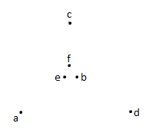

Figure 62. Representation on the landing pad beacons

|  |  |  |  |  |  |  |
| --- | --- | --- | --- | --- | --- | --- |
| **Point** | **a** | **b** | **c** | **d** | **e** | **f** |
| **a** | 0 | 4 | 6 | 6 | 4 | 4 |
| **b** | 4 | 0 | 4 | 4 | 1 | 1 |
| **c** | 6 | 4 | 0 | 6 | 4 | 4 |
| **d** | 6 | 4 | 6 | 0 | 4 | 4 |
| **e** | 4 | 1 | 4 | 4 | 0 | 1 |
| **f** | 4 | 1 | 4 | 4 | 1 | 0 |
| **Totals** | 24 | 14 | 24 | 24 | 14 | 14 |

Figure 63. Matrix of lengths to find the inner beacons

The lengths between the coordinates are calculated as before with the CalculatePixelLengthBetweenPoints() method. Similar to before, the centre of these inner beacons is found and the unit vector is recalculated relative to the centre of the image.

Next the _currentRelativeHeightMetres is calculated using the inner target coordinates and the CalculateAverageRelativeHeightInnerTargets() method. The premise here is that an average relative height from the UAV to the individual line segments would give an approximation of the relative height of the centre point of the three inner coordinates. As before cross product is used here and then averaged.

linePixelLength = (double)CalculatePixelLengthBetweenPoints(listOfInnerPoints[0], listOfInnerPoints[1]);

realWorldImageLineSizeMetres = (linePixelLength / pixelsPerMm) * _mmToMetres;

TotalRelativeHeight += beaconDistanceMetres * (ImageDataSingleton.GetInstance().FocalLengthMm * _mmToMetres)

/ realWorldImageLineSizeMetres;

linePixelLength = (double)CalculatePixelLengthBetweenPoints(listOfInnerPoints[0], listOfInnerPoints[2]);

realWorldImageLineSizeMetres = (linePixelLength / pixelsPerMm) * _mmToMetres;

TotalRelativeHeight += beaconDistanceMetres * (ImageDataSingleton.GetInstance().FocalLengthMm * _mmToMetres)

/ realWorldImageLineSizeMetres;

linePixelLength = (double)CalculatePixelLengthBetweenPoints(listOfInnerPoints[1], listOfInnerPoints[2]);

realWorldImageLineSizeMetres = (linePixelLength / pixelsPerMm) * _mmToMetres;

TotalRelativeHeight += beaconDistanceMetres * (ImageDataSingleton.GetInstance().FocalLengthMm * _mmToMetres)

/ realWorldImageLineSizeMetres;

relativeHeight = TotalRelativeHeight / 3;

Based on this average relative height and any previous relative height, a decision is made on the decent rate to achieve touchdown.

if (_previousRelativeHeightMetres == 0)

{

_previousRelativeHeightMetres = _currentRelativeHeightMetres;

}

else if (_previousRelativeHeightMetres > _currentRelativeHeightMetres + (_landingAltitudeAdjustment * 1.1))

{

_previousRelativeHeightMetres = _currentRelativeHeightMetres;

_incrementArray[1] = FlightSingleton.GetInstance().ArrestedDecentRate;

}

else

{

_previousRelativeHeightMetres = _currentRelativeHeightMetres;

if (_currentRelativeHeightMetres < _10Metres)

{

_incrementArray[1] = FlightSingleton.GetInstance().DecentRateStage2;

}

else

{

_incrementArray[1] = FlightSingleton.GetInstance().DecentRate;

}

}

Each iteration (frame) makes small changes to the UAV’s position and this continues until touchdown.

There were some issues when processing coordinates obtained at lower resolution and data integrity, this is discussed later in the chapter Issues and Impediments. To handle these issues a structure was put in place to drop any bad frames. Each operation checks to see if the frame is good before processing it. A count of dropped frames is maintained and if the _maxBadFramesValue in twenty consecutive frames (approximately one second) is achieved, the UAV gains altitude and all operations are locked until the desired altitude is achieved. The process then starts again.

if (_frameResultLast20.Count >= 20)

{

foreach (bool result in _frameResultLast20)

{

if(result)

{

_frameTotal++;

}

else

{

_frameTotal--;

}

}

if (_frameTotal <= _maxBadFramesValue) // negative is used for false

{

GainAltitudeAndCentre();

}

_frameResultLast20.Clear();

_frameTotal = 0;

}

And,

private void GainAltitudeAndCentre()

{

if (!_isGainAltidudeLockOn)

{

_isGainAltidudeLockOn = true;

}

if (_uavCoordinatesFullSet[1] >= _newAbortRequiredAltitude)

{

_isGainAltidudeLockOn = false;

}

else

{

// Increase Altitude

_incrementArray[0] = _landingHorizontalAdjustmentSpeed;

_incrementArray[1] = _intercepClimbRate;

_incrementArray[2] = _landingHorizontalAdjustmentSpeed;

_incrementArray[3] = 0.0;

_uavXzDoubleCoordinates[0] = _uavCoordinatesFullSet[0];

_uavXzDoubleCoordinates[1] = _uavCoordinatesFullSet[2];

_shipXzDoubleCoordinates[0] = _shipCoordinatesFullSet[0];

_shipXzDoubleCoordinates[1] = _shipCoordinatesFullSet[2];

_xzUnitVector = _trajectoryUnitVector.GetUnitVector(_uavXzDoubleCoordinates, _shipXzDoubleCoordinates);

}

}

At the end of each iteration, the increment and unit-vector arrays are pushed to the FlightSingleton class.

FlightSingleton.GetInstance().XzUnitVector = _xzUnitVector;

FlightSingleton.GetInstance().IncrementArray = _incrementArray;

## 13.11 PC 2 – The Propulsion Class

Once the propulsion thread is set up, the Propulsion class iterates on a continuous basis (until touchdown). For each iteration, the increment and unit-vector arrays are pulled down from the FlightSingleton class. The values from these arrays are applied to the current coordinates and the results are pushed to the InsSimulationSingleton class. As stated before the x, z values are a product of their increment and unit-vector values.

_tempDouble = (double)(_currentIncrement[0] * _xzVector[0]);

if (!Double.IsNaN(_tempDouble))

{

_currentPosition[0] += _tempDouble;

}

_tempDouble = (double)(_currentIncrement[2] * _xzVector[1]);

if (!Double.IsNaN(_tempDouble))

{

_currentPosition[2] += _tempDouble;

}

The checks for NaN (not a number) were used here to ensure that only valid data was passed to the InsSimulationSingleton. Issues where encountered at lower resolutions and the bad data propagated the system via the singletons. This is discussed further later.

## 13.12 PC 2 – Sending the UAV Coordinates

The newly generated coordinates are posted to the other PC in an similar fashion to the process employed by PC 1. The UAVSendController first pulls the coordinate array from the InsSimulationSingleton and passes them to the StartSender() method in the UDPSender class. This continues at balanced intervals until the UAV has touched down.

# 14. Implemented Tests

|  |  |  |
| --- | --- | --- |
| No. | Test | Class |
|  | **Unity Application Tests** |  |
| 1 | TestSelectRangeForHeight_S_S_Six | SeaStateSix |
| 2 | TestSelectRangeForWavelength_S_S_Six |  |
| 3 | TestSelectRangeForWaveSpeed_S_S_Six |  |
| 4 | TestNewWaveStatistics_S_S_Six |  |
| 5 | TestSelectRangeForHeight_S_S_Three | SeaStateThree |
| 6 | TestSelectRangeForWavelength_S_S_Three |  |
| 7 | TestSelectRangeForWaveSpeed_S_S_Three |  |
| 8 | TestNewWaveStatistics_S_S_Three |  |
| 9 | TestNewWaveStatistics_S_S_Zero | SeaStateZero |
| 10 | TestCalculateRelativeSpeed_Setup1 | ShipMotion |
| 11 | TestCalculateRelativeSpeed_Setup2 |  |
| 12 | TestCalculateRelativeSpeed_Setup3 |  |
| 13 | TestPopulateHeaveArray_S_S_6 |  |
| 14 | TestPopulateHeaveArray_S_S_3 |  |
| 15 | TestPopulateHeaveArray_S_S_0 |  |
| 16 | TestPopulatePitchArray_S_S_6 |  |
| 17 | TestPopulatePitchArray_S_S_3 |  |
| 18 | TestPopulatePitchArray_S_S_0 |  |
| 19 | TestPopulateRollArray_S_S_6 |  |
| 20 | TestPopulateRollArray_S_S_3 |  |
| 21 | TestPopulateRollArray_S_S_0 |  |
|  |  |  |
|  | **Visual Studio Application Tests** |  |
| 22 | TestGetStageTwoIntercept1 | ControlUnit |
| 23 | TestGetStageTwoIntercept2 |  |
| 24 | TestGetStageTwoIntercept3 |  |
| 25 | TestGetStageTwoIntercept4 |  |
| 26 | TestGetStageTwoIntercept5 |  |
| 27 | TestCalculateLengthBetweenPoints |  |
| 28 | TestFindInnerTarget1 |  |
| 29 | TestFindInnerTarget2 |  |
| 30 | TestFindInnerTarget3 |  |
| 31 | TestGetCentreOfBeacons |  |
| 32 | TestFindPointsForLongestLineSegment1 |  |
| 33 | TestFindPointsForLongestLineSegment2 |  |
| 34 | TestStartLanding | ControlUnit |
| 35 | TestGetCalculationData1 | ImageSimulation |
| 36 | TestGetCalculationData2 |  |
| 37 | TestGetCalculationData3 |  |
| 38 | TestGetCalculationData4 |  |
| 39 | TestCalculateParameterT |  |
| 40 | TestCalculateImageCoordinate |  |
| 41 | TestMapCoordinatesToPixels |  |
| 42 | TestTranslatePointsForRelativeRotation1 |  |
| 43 | TestTranslatePointsForRelativeRotation2 |  |
| 44 | Test270Degrees | Rotation |
| 45 | Test180Degrees |  |
| 46 | Test0Degrees |  |
| 47 | Test90Degrees |  |
| 48 | TestCalculateVectorLength | TrajectoryUnitVector |
| 49 | TestCalculateUnitVector |  |

Figure 64 Implementated Unit Tests

There is an issue when trying to run tests with the Unity application. Each time the project is closed the test folder is dropped. To run the test the folder will need to be placed in the right folder and then imported through the solution (Visual Studio editor).

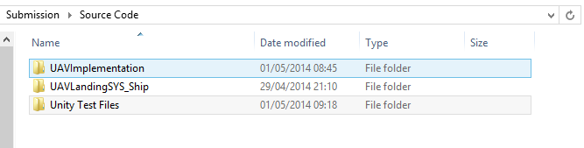

Figure 65 Test Files Folder

Inside this folder is the TestBusinessLayer folder which needs to be COPIED and placed into the UAVLandingSYS_Ship folder and copied into the inner ShipImplementation folder. After this has been completed the files can be accessed by RIGHT clicking on the solution name in the Solution Browser (Visual Studio editor) and select ‘Add’ and the ‘Existing Porject’ any navigate to the test files added to the ShipImplementation folder.

As most of the methods tested had private modifiers, the use of reflection was required. Reflection invokes the methods by the string value of their name also any private fields required for the tests also required reflection to be used. In order to run some of the test it was necessary to disable the while loops they contained, this involved setting the value for Is IsTouchdown and IsImageCoordinatesReceived in the Flight an Image singletons.

# 15. Research Results

## 15.1 Result Set 1

Configuration:

Sea State 6

Wave Direction 0 Degrees

Speed Full

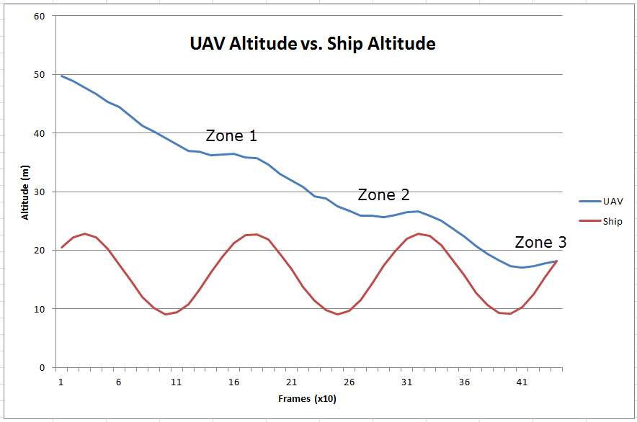

Figure 66. Result Set 1 - Sea State 6

The graph clearly shows in zones 1 and 2 that the UAV has interpreted the upward motion of the ship and arrested the decent. This also happens prior to touch down Zone 3 and as a result the impact at touchdown would be reduced.

|  |  |  |
| --- | --- | --- |
| Frame Count (x10) | UAV Altitude (m) | Landing Pad Altitude (m) |
| 1 | 49.75 | 20.45 |
| 2 | 48.9 | 22.26 |
| 3 | 47.8 | 22.81 |
| 4 | 46.65 | 22.17 |
| 5 | 45.3 | 20.3 |
| 6 | 44.4 | 17.56 |
| 7 | 42.8 | 14.88 |
| 8 | 41.2 | 12.04 |
| 9 | 40.3 | 10.16 |
| 10 | 39.2 | 9.111 |
| 11 | 38.1 | 9.409 |
| 12 | 36.95 | 10.74 |
| 13 | 36.85 | 13.21 |
| 14 | 36.25 | 16.23 |
| 15 | 36.4 | 18.84 |
| 16 | 36.5 | 21.26 |
| 17 | 35.9 | 22.62 |
| 18 | 35.75 | 22.73 |
| 19 | 34.65 | 21.81 |
| 20 | 33.05 | 19.34 |
| 21 | 31.9 | 16.8 |
| 22 | 30.8 | 13.76 |
| 23 | 29.2 | 11.43 |
| 24 | 28.8 | 9.783 |
| 25 | 27.45 | 9.061 |
| 26 | 26.8 | 9.694 |
| 27 | 25.95 | 11.57 |
| 28 | 25.85 | 14.31 |
| 29 | 25.7 | 17.38 |
| 30 | 26.05 | 19.84 |
| 31 | 26.45 | 21.91 |
| 32 | 26.59 | 22.8 |
| 33 | 25.94 | 22.46 |
| 34 | 25.09 | 20.86 |
| 35 | 23.74 | 18.3 |
| 36 | 22.34 | 15.65 |
| 37 | 20.74 | 12.7 |
| 38 | 19.34 | 10.62 |
| 39 | 18.24 | 9.252 |
| 40 | 17.34 | 9.136 |
| 41 | 16.99 | 10.26 |
| 42 | 17.34 | 12.52 |
| 43 | 17.74 | 15.45 |
| 44 | 18.14 | 18.12 |

Figure 67. Result Set 1 - Sea State 6 Data

## 15.2 Result Set 2

Configuration:

Sea State 6

Wave Direction 45 Degrees

Speed Full

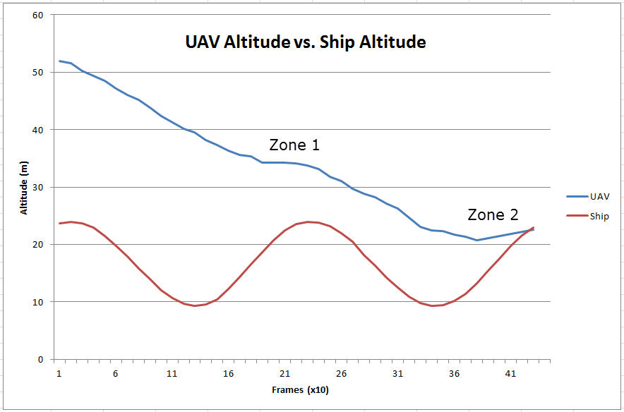

Figure 68. Result Set 2 - Sea State 6

Similar to result set 1 the UAV has slowed its decent when a rise in the ship has been detected. There are fewer waves in this set as they are approaching at 45 degrees and so the wavelength is extended.

When result sets 1 and 2 are compared to sets 3 and 4 the motion in sea state 6 is not as fluid. It is assumed there is more micro management of the flight alterations required.

|  |  |  |
| --- | --- | --- |
| Frame Count (x10) | UAV Altitude (m) | Landing Pad Altitude (m) |
| 1 | 52 | 23.688 |
| 2 | 51.6 | 23.975 |
| 3 | 50.25 | 23.676 |
| 4 | 49.4 | 22.902 |
| 5 | 48.5 | 21.517 |
| 6 | 47.15 | 19.718 |
| 7 | 46 | 17.923 |
| 8 | 45.15 | 15.767 |
| 9 | 43.8 | 13.923 |
| 10 | 42.4 | 12.026 |
| 11 | 41.3 | 10.683 |
| 12 | 40.2 | 9.6501 |
| 13 | 39.55 | 9.2746 |
| 14 | 38.2 | 9.5873 |
| 15 | 37.35 | 10.443 |
| 16 | 36.3 | 12.231 |
| 17 | 35.65 | 14.303 |
| 18 | 35.3 | 16.608 |
| 19 | 34.2 | 18.627 |
| 20 | 34.3 | 20.725 |
| 21 | 34.2 | 22.403 |
| 22 | 34.1 | 23.512 |
| 23 | 33.7 | 23.946 |
| 24 | 33.1 | 23.864 |
| 25 | 31.75 | 23.168 |
| 26 | 31.1 | 21.907 |
| 27 | 29.75 | 20.432 |
| 28 | 28.9 | 18.187 |
| 29 | 28.25 | 16.307 |
| 30 | 27.15 | 14.179 |
| 31 | 26.249 | 12.47 |
| 32 | 24.649 | 10.852 |
| 33 | 23.05 | 9.8515 |
| 34 | 22.4 | 9.2957 |
| 35 | 22.3 | 9.4395 |
| 36 | 21.7 | 10.146 |
| 37 | 21.3 | 11.351 |
| 38 | 20.7 | 13.224 |
| 39 | 21.05 | 15.441 |
| 40 | 21.45 | 17.483 |
| 41 | 21.85 | 19.716 |
| 42 | 22.2 | 21.627 |
| 43 | 22.6 | 22.892 |

Figure 69. Result Set 2 - Sea State 6 Data

## 15.3 Result Set 3

Configuration:

Sea State 3

Wave Direction 0 Degrees

Speed Half

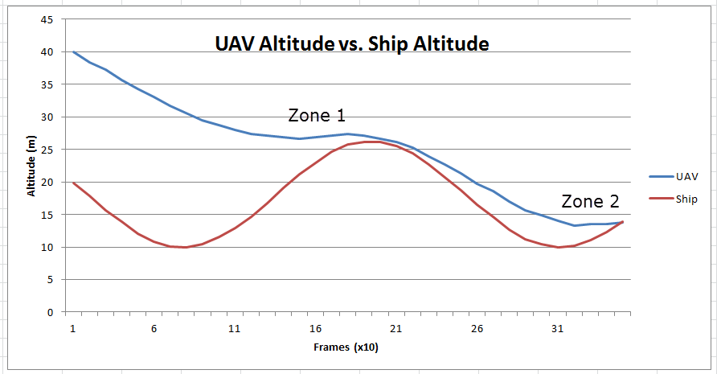

Figure 70. Result Set 3 - Sea State 3

It can be seen here that the amplitude of the waves is lower for sea state 3. At Zone 1 the UAV comes close to landing but this is not actually achieved until it reaches zone 2.

|  |  |  |
| --- | --- | --- |
| Frame Count (x10) | UAV Altitude (m) | Landing Pad Altitude (m) |
| 1 | 40.02 | 19.87 |
| 2 | 38.42 | 17.89 |
| 3 | 37.25 | 15.65 |
| 4 | 35.65 | 13.84 |
| 5 | 34.25 | 12.09 |
| 6 | 33.11 | 10.81 |
| 7 | 31.74 | 10.1 |
| 8 | 30.57 | 10 |
| 9 | 29.43 | 10.47 |
| 10 | 28.75 | 11.55 |
| 11 | 28.04 | 12.92 |
| 12 | 27.36 | 14.6 |
| 13 | 27.14 | 16.77 |
| 14 | 26.89 | 19.05 |
| 15 | 26.67 | 21.25 |
| 16 | 26.88 | 22.98 |
| 17 | 27.12 | 24.6 |
| 18 | 27.36 | 25.71 |
| 19 | 27.11 | 26.19 |
| 20 | 26.66 | 26.14 |
| 21 | 26.18 | 25.58 |
| 22 | 25.27 | 24.4 |
| 23 | 23.9 | 22.73 |
| 24 | 22.73 | 20.7 |
| 25 | 21.36 | 18.74 |
| 26 | 19.76 | 16.48 |
| 27 | 18.59 | 14.59 |
| 28 | 16.99 | 12.7 |
| 29 | 15.59 | 11.23 |
| 30 | 14.91 | 10.38 |
| 31 | 14 | 10 |
| 32 | 13.29 | 10.16 |
| 33 | 13.53 | 11.08 |
| 34 | 13.51 | 12.29 |
| 35 | 13.75 | 13.84 |

Figure 71. Result Set 3 - Sea State 3 Data

## 15.4 Result Set 4

Configuration:

Sea State 0

Wave Direction 0 Degrees

Speed Stop

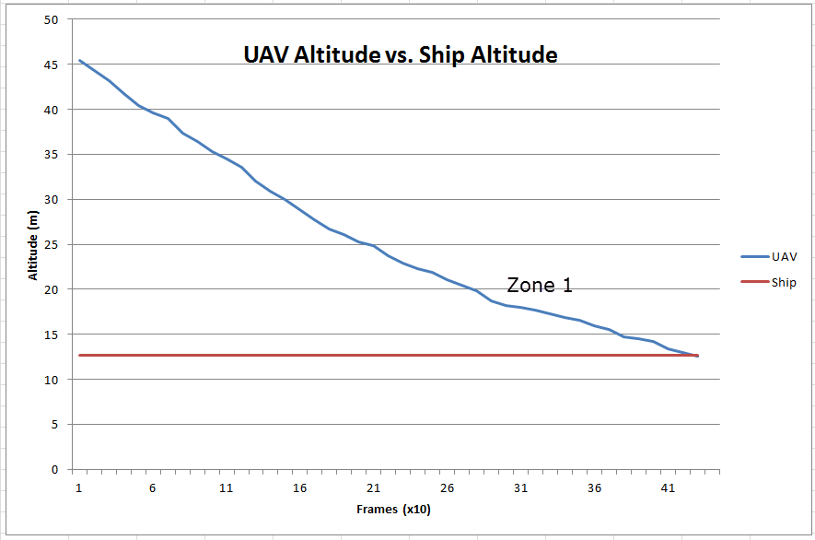

Figure 72. Result Set 4 - Sea State 0

In this unlikely scenario the ship is completely still and the UAV descends relatively uniformly. It can be clearly see that the decent rate is slowed at Zone 1 as the UAV approaches the deck of the ship.

The results above and the visual display of the application illustrate that this simulation of the autonomous landing of a UAV can establish a successful touchdown based on the relative altitude of the UAV above the ship. While inspecting the simulated landing on both the graphs and the visual display, the arrested decent can clearly be seen to aid the UAV model as the ship pitches and rolls as it interacts with simulated ocean waves.

|  |  |  |
| --- | --- | --- |
| Frame Count (x10) | UAV Altitude (m) | Landing Pad Altitude (m) |
| 1 | 45.4 | 12.7 |
| 2 | 44.3 | 12.7 |
| 3 | 43.2 | 12.7 |
| 4 | 41.8 | 12.7 |
| 5 | 40.45 | 12.7 |
| 6 | 39.6 | 12.7 |
| 7 | 38.95 | 12.7 |
| 8 | 37.35 | 12.7 |
| 9 | 36.45 | 12.7 |
| 10 | 35.35 | 12.7 |
| 11 | 34.5 | 12.7 |
| 12 | 33.6 | 12.7 |
| 13 | 32 | 12.7 |
| 14 | 30.9 | 12.7 |
| 15 | 30 | 12.7 |
| 16 | 28.9 | 12.7 |
| 17 | 27.75 | 12.7 |
| 18 | 26.65 | 12.7 |
| 19 | 26.05 | 12.7 |
| 20 | 25.25 | 12.7 |
| 21 | 24.85 | 12.7 |
| 22 | 23.75 | 12.7 |
| 23 | 22.9 | 12.7 |
| 24 | 22.25 | 12.7 |
| 25 | 21.9 | 12.7 |
| 26 | 21.1 | 12.7 |
| 27 | 20.5 | 12.7 |
| 28 | 19.85 | 12.7 |
| 29 | 18.75 | 12.7 |
| 30 | 18.15 | 12.7 |
| 31 | 18 | 12.7 |
| 32 | 17.65 | 12.7 |
| 33 | 17.25 | 12.7 |
| 34 | 16.9 | 12.7 |
| 35 | 16.55 | 12.7 |
| 36 | 15.95 | 12.7 |
| 37 | 15.55 | 12.7 |
| 38 | 14.7 | 12.7 |
| 39 | 14.55 | 12.7 |
| 40 | 14.2 | 12.7 |
| 41 | 13.35 | 12.7 |
| 42 | 12.95 | 12.7 |
| 43 | 12.6 | 12.7 |

Figure 73. Result Set 4 - Sea State 0 Data

# 16. Challenges, Issues and Impediments

During this project a number of obstacles where encountered. These included developing and testing with the Unity application, image processing, multi-thread programming and the scope of the project.

## 16.1 Developing with Unity

The Unity game engine is a substantial application and proved challenging with no previous knowledge. The Unity website has significant resources to help gain the required knowledge to develop games. Some of these resources and in particular Unity’s API / Scripting Reference (Unity, 2014) prove useful. The application for Unity was developed using the Visual Studio editor. Scripts that interact directly with the interface need to implement the MonoBehaviour interface. This makes unit testing difficult with the affected classes. The system was set up in a tiered structure with only the presentation layer implementing the MonoBehaviour interface. This allowed testing to be carried out on the other layers.

To debug a Unity project the use of the MonoDevelop editor is required. This was used sparingly as the process was not intuitive. The debugging functionality in the Visual Studio editor is not directly available, however a work around was discovered. It was possible to debug into the unit tests and then subsequently into the actual code. Also it is not possible to output to the Console window of Visual Studio editor precluding manual testing and is only available in the Unity console from the classes that implement the MonoBehaviour interface.

## 16.2 Image Processing

As discussed in section 13.9 Processing the Ship Coordinates, there were, what appear to be hardware issues with the machine used to develop this project and processing multiple images simultaneously. There are other options for parallel processing, for example utilising the PC GPU, however this functionality was not supported by the PC’s graphics card. The feasibility of reducing the camera chip size and the chip resolution was investigated but, although the times improved and seemed acceptable the number of bad frames, discussed in section 13.9 Processing the Ship Coordinates, increased dramatically.

Supported by the understanding that the generation and processing of images would normally happen on separate machines, a decision was made to bypass the implementation of this functionality, the code is however included in the source code.

## 16.3 Multi-Thread Programming

To model some of the operations carried out by an aircraft of this type, four separate threads are instantiated and continuously run until the notification that the aircraft has touch down is received. To share the data required by the system’s components three singleton classes needed to be setup. These singletons have double check locking to prevent issues with data integrity however if bad data did get pushed to a singleton it was then propagated through the system. When the image processing issue was being investigated errors with data where observed. Doubles with values of NaN (not a number) where being added to the collection processed by the system. When this was discovered checks were put in place to prevent this including explicitly checking for NaN and a safe version of a double to int conversion. Also the _isGoodFrame check was implemented in the control unit class. Before the issue was resolved it was observed that performance was improved if threads processing points in loops were put to sleep, e.g. 5ms between iterations. This was only an observation but did provide improvements.

## 16.4 Project Scope

The scope of this project i.e. modelling the flight of a helicopter was acknowledged to be significant from the start of the development phase. This scope had a bearing on what features of the UAV’s flight and the ship’s motion were implemented. It was decided not to implement roll or pitch rotations for the UAV, forward motion of the ship (although the effects of relative speed and direction between the ship and waves was included), or the efforts of wind, drag and turbulence on both craft. If this project was developed further these characteristics would need to be considered.

# 17. Project Management Diary

## 17.1 Literature Review Diary

|  |  |
| --- | --- |
| Date (M-S) | Work Items |
| September |  |
| 16-22 | Formulated project idea and submitted the project vision statement |
| 23-29 | Initial research carried out for the project. Concerns where expressed about the scope of the project. |
| October |  |
| 30-6 | Research into the operational parameters of ships and UAVs |
| 7-13 | Further research and document development |
| 14-20 | Further research and document development |
| 21-27 | Submitted the Project Proposal Document including an outline TOC, introduction and the project research question |
| 28-3 | Evaluated trajectory computations and further research |
| November |  |
| 4-10 | Development of risk analysis and design documents |
| 11-17 | Submission of the Project Plan including one complete chapter, risk analysis, implementation objectives and preliminary design documents |
| 18-24 | Developed a prototype is the proposed system with Unity and Visual Studio |
| 25-1 | Evaluation of the mathematical models involved in the project and further development of design documents |
| December |  |
| 2-8 | Document development and editing |
| 9-15 | Literature Review submission |
| 16-22 | Literature Review and prototype presentation |

## 17.2 Implementation Diary

|  |  |
| --- | --- |
| Date (M-S) | Work Items |
| January |  |
| 13-19 | The initial setup up of the ship implementation was established. This involved a tiered framework with the presentation layer alone implementing the Unity ‘MonoDevelop’ interface. |
| 20-26 | Work continued on the project framework. In the Ship implementation data for the motion of the ship model is generated considering external forces and passed to the ship model in the presentation layer model. Work also commenced on testing for the business layer. |
| 27-2 | The motion algorithms for the ship motion where further refined and integrated into the Unity model script. This proved complicated and the dependencies between the different ‘GameObject’ movement controls had undesirable affects. Further work on the test for this implementation. |
| February |  |
| 3-9 | The bi-directional UDP communication was established between the UAV implementation and the ship implementation on the two PCs |
| 10-16 | An application test rig for the image generation was developed. |
| 17-23 | Further refinement on the image test rig. Started work on testing for the image simulation component of the project. |
| 24-2 | The image test rig was integrated into the UAV implementation. Further work was also carried out on the testing of the UAV business layer. |
| March |  |
| 3-9 | The image generation component to the project and testing is complete and tested. Presentation to superior and demonstration of partially complete video log for the project. |
| 10-16 | Work commenced on the image processing. This proved problematic and is discussed elsewhere. Refactoring to remove image processing from the implementation. |
| 17-23 | Developing the project implementation. |
| 24-30 | Developing the project implementation. |
| April |  |
| 31-6 | Developing the project implementation. The UAV is now decenting. This motion has to be refined further. |
| 7-13 | Work commenced on the substantial refactoring of the main algorithms and ControlUnit and Propulsion classes |
| 14-20 | Work continues on the navigation section of the system. The Unity model was refined and the motion for the UAV model was finalised. |
| 21-27 | Final work on the project prior to submission. |
| May | Project submission. |

# Conclusion

The use of unmanned aircraft is getting more and more prevalent in the scientific, environmental, civil, public and military sectors. Landing an unmanned aircraft is, more often than not, undertaken by a land or ship based pilot. This task is far more complex on a moving ship rather than on land and the level of success of a deck landing is relative to the pilot’s experience and the sea state at the time of landing. A number of approaches can be undertaken here and include sacrificial struts on the landing gear of the UAV, killing the power close to the deck and letting the inertia of the rotors lower the UAV at a somewhat acceptable rate, and/or advanced pilot skill to perform a full manual landing. Non-autonomous landings on a moving platform pose a threat to the UAV and possibly their surroundings as well, as the rotors spin at very high velocities.

Full autonomous landings could help with these issues and is a relatively new addition to the UAV market. As stated earlier, only two years ago Boeing claimed to be the first company to perform a fully autonomous landing of a VTAL UAV on the deck of a ship (NovAtel, 2012). Also autonomous landings would negate any effect human response times may have on a planned landing.

There are a small number of systems now available on the market. Sensory data is obtained from a number of sources including ultrasound, radar, local positioning systems and image recognition. The simulation developed for this project investigates to use of image recognition in conjunction with infrared markers on the deck of the ship. It is felt that this system is a viable option as the UAV would probably already be fitted with some of the hardware required to perform the required tasks. It would be standard to have a camera on an unmanned UAV for navigation purposes, with data processing power, navigation and connectivity units to relay coordinates. Depending on the processing power existing in the UAV a retro fit for a system similar to the simulation proposed here may not require a lot more than minor hardware adjustments and installing an application on the UAV processor. The infrared beacons would need to be fitted to the deck of the ship but they could be temporary and only rolled out e.g. on a landing mat, when a landing is imminent.

The simulation shows that a system similar to this if deployed would reduce the force of any impact as the model was observed gaining altitude at the point of landing. This could be further developed with processes like Q-Learning or machine learning where the system could start to move proactively rather than reactively and the opportune time and coordinates for a successful landing could be estimated.

To develop this project further it would probably be advisable to develop the application on a Maths based IDE e.g. MathLab, to provide detailed data for the multiple variables involved in helicopter flight. Unity served well as a means to visually display the interaction of the UAV and the ship and demonstrate a possible means to assist in the landing of a VTOL UAV on the deck of an ocean going ship. Also the motion for the model of the ship was simulated in a somewhat sterile fashion based on a sinusoidal wave, albeit with some variance for certain sea states.

For this simulation maximum and minimum values for pitch and roll of a ship in certain sea states was obtained from an online source If real time data could be obtained this would further develop the validity of the simulation. This could be achieved by placing a smartphone (or other capable device) with a gyroscope and accelerometer on a ship

# Appendix

## Appendix 1 Douglas Sea Scale

Douglas Sea Scale (Met Office, 2010)

|  |  |  |  |
| --- | --- | --- | --- |
| Code | Height (m) | Sea State | Swell Description |
| 0 | 0 | Calm (glassy) | No Swell |
| 1 | 0 - 0.1 | Calm (rippled) | Very low (short and low wave) |
| 2 | 0.1 - 0.5 | Smooth (wavelets) | Low (long and low wave) |
| 3 | 0.5 - 1.25 | Slight | Light (short and moderate wave) |
| 4 | 1.25 - 2.5 | Moderate | Moderate (average and moderate wave) |
| 5 | 2.5 - 4.0 | Rough | Moderate rough (long and moderate wave) |
| 6 | 4.0 - 6.0 | Very rough | Rough (short and heavy wave) |
| 7 | 6.0 - 9.0 | High | High (average and heavy wave) |
| 8 | 9.0 - 14.0 | Very high | Very high (long and heavy wave) |
| 9 | Over 14.0 | Phenomenal | Confused (wave length and height indefinable) |

# Works Cited

AMD. (2014). *Getting Started with OpenCL*. Retrieved March 15, 2014, from AMD - Developer Central: http://developer.amd.com/resources/heterogeneous-computing/opencl-zone/getting-started-with-opencl/

Astrium. (2013, July 10). *Key Features*. Retrieved November 28, 2013, from DeckFinder: http://deckfinder.net/key-features/

Biven, C. C., & Guercio, J. G. (1987). *A Simulation Investigation of Scout/Attack Helicopter Directional Control Requirements for Hover and Low-Speed Tasks.* California: National Aeronautics and Space Administration. Retrieved November 4, 2013, from https://www.google.ie/url?sa=t&rct=j&q=&esrc=s&source=web&cd=10&cad=rja&sqi=2&ved=0CGUQFjAJ&url=http%3A%2F%2Fwww.dtic.mil%2Fcgi-bin%2FGetTRDoc%3FAD%3DADA185874&ei=Mw59UuHCIIqV7Qa5s4DAAg&usg=AFQjCNHJ8Z4-ncgeOfiU-7ki8WCqHVN4Iw&bvm=bv.56146854,d.ZGU

Blender. (2013, October 31). *Blender 2.69*. Retrieved November 24, 2013, from Blender: http://www.blender.org/download/

Blender. (2014). *Blender*. Retrieved from Blender: http://www.blender.org/

Din, A., Bona, B., Morrissette, J., Hussain, M., Violante, M., & Naseem, F. (2012). Embedded Low Power Controller for Autonomous Landing of Small UAVs using Neural Networks. *10th International Conference on Frontiers of Information Technology* (pp. 196-203). Islamabad: Conference Publishing Services & IEEE Computer Society. Retrieved October 6, 2013, from http://0-ieeexplore.ieee.org.acpmil13web.ancheim.ie/stamp/stamp.jsp?tp=&arnumber=6424321

Esmailifar, S. M., & Saghafi, F. (2009). Autonomous Unmanned Helicopter Landing System Design for Safe Touchdown on 6DOF Moving Platform. *Fifth International Conference on Autonomic and Autonomus Systems* (pp. 245-250). Valencia: IEEE. Retrieved October 26, 2013, from http://0-ieeexplore.ieee.org.acpmil13web.ancheim.ie/stamp/stamp.jsp?tp=&arnumber=4976611

Fang, R., Krijns, W., Finch, R. S., Geyer, W. P., Long, K., & Carico, D. (2003). *Helicopter/Ship Qualification Testing.* North Atlantic Treaty Organisation/Research and Technology Organisation, The Research and Technology Organisation (RTO) of NATO. Ottawa: St. Joseph Print Group Inc. Retrieved October 19, 2013, from https://www.google.ie/url?sa=t&rct=j&q=&esrc=s&source=web&cd=1&cad=rja&ved=0CCwQFjAA&url=http%3A%2F%2Fwww.dtic.mil%2Fcgi-bin%2FGetTRDoc%3FAD%3DADA411975&ei=W6hiUoalA8eshQe1yICYCw&usg=AFQjCNH8bYfwU1lJw8j0ueLwmMsj89JhLQ&bvm=bv.54934254,d.ZG4

Federal Aviation Administration. (2012). *Helicopter Flying Handbook.* Oklahoma City: United States Department of Transportation. Retrieved November 4, 2013, from http://www.faa.gov/regulations_policies/handbooks_manuals/aviation/helicopter_flying_handbook/media/helicopter_flying_handbook.pdf

Florida Centre for Instructional Technology. (2005). *Waves in the Ocean.* Retrieved November 15, 2013, from fcit.usf.edu: http://fcit.usf.edu/florida/teacher/science/mod2/resources/waves.pdf

Herissé, B., Hamel, T., Mahony, R., & Russotto, F.-X. (2012). Landing a VTOL Unmanned Aerial Vehicle on a Moving Platform Using Optical Flow. *Robotics, IEEE Transactions on (Volume:28 , Issue: 1 ), 28*(1), 77-89. doi:10.1109/TRO.2011.2163435

Hood Tech Vision. (2013). *Hood Tech Vision Product Summary Table.* Retrieved November 9, 2013, from www.hoodtechvision.com: http://www.hoodtechvision.com/products.html

IPython. (2013, September). *IPython Interactive Computing*. Retrieved November 24, 2013, from ipython.org: http://ipython.org/

Kamalasadan, S., & Ghandakly, A. A. (2011). A Neural Network Parallel Adaptive Controller for Fighter Aircraft Pitch-Rate Tracking. *Instrumentation and Measurement, IEEE Transactions on* , 258-267. doi:10.1109/TIM.2010.2047310

Kearfoot. (2011, August). *KN-4072A Airborne INS/GPS*. Retrieved November 9, 2013, from www.kearfott.com: http://www.kearfott.com/images/stories/pdf/DATASHEETS_KGN_NJ/AIR/kn-4072a_avionics_ins-gps.pdf

Lobik, M. D. (2003, March 14). *Helicopter Dynamic Rollover.* Retrieved November 20, 2013, from Nav Air: http://www.navair.navy.mil/safety/toolkit.cfm

MathWorks. (2013). *MatLab 30-Day Free Trial*. Retrieved November 24, 2013, from MathWorks: http://www.mathworks.co.uk/programs/nrd/matlab-trial-request.html?ref=ggl&s_eid=ppc_6060

McDonald, M. (1993). *SHF SATCOM Terminal Ship-Motion Study.* Technical Report, United States Navy, Naval Command, Control and Ocean Surveillance Centre, San Diego. Retrieved September 27, 2013, from http://www.spawar.navy.mil/sti/publications/pubs/tr/1578/tr1578.pdf

Met Office. (2010). *The Beaufort Scale.* Retrieved October 10, 2013, from www.metoffice.gov.uk: http://www.metoffice.gov.uk/media/pdf/b/7/Fact_sheet_No._6.pdf

Microsoft. (2014). *Visual Studio*. Retrieved from Visual Studio: http://www.visualstudio.com/

NovAtel. (2012). *Automated Flight Control System*. Retrieved November 28, 2013, from www.novatel.com: http://www.novatel.com/technology-in-action/automated-flight-control/

NUnit. (2013, October 10). *NUnit - Home*. Retrieved from www.nunit.org: http://nunit.org/index.php?p=home

Padfield, G. D. (2007). *Helicopter Flight Dynamics* (2nd ed.). Oxford: Blackwell Publishing. Retrieved October 12, 2013, from http://www.foinikas.org/ftp/public/DCS%20Blackshark/HELICOPTER%20FLIGHT%20DYNAMICS.pdf

Prism Defence. (2010). *Prism Defence*. Retrieved November 20, 2013, from www.prismdefence.com: http://www.prismdefence.com/index.html

pythonxy. (2013, November 21). *Downloads*. Retrieved November 24, 2013, from pythonxy Scientific-oriented Python Distribution based on Qt and Spyder: https://code.google.com/p/pythonxy/wiki/Downloads?tm=2

Rotomotion. (2009, November). *SR200 Helicopter UAV Specifications.* Retrieved from www.rotomotion.com: http://www.rotomotion.com/datasheets/sr200_uav_sheet.pdf

Rotomotion. (2011, Feburary 14). *SR 200*. Retrieved from www.Rotomotion.com: http://www.rotomotion.com/r_product_5_sr200.html

Sakhal. (2014). *Arleigh Burke class*. Retrieved March 7, 2014, from American Cruisers and Destroyers: http://www.shippictures.byethost22.com/american%20destroyers.htm

Sanchez-Lopez, J. L., Saripalli, S., Campoy, P., Pestana, J., & Fu, C. (2013). Toward visual autonomous ship board landing of a VTOL UAV. *Unmanned Aircraft Systems (ICUAS), 2013 International Conference on* (pp. 779-788). Atlanta: IEEE. doi:10.1109/ICUAS.2013.6564760

Sandino, L. A., Bejar, M., & Ollero, A. (2011). On the applicability of linear control techniques for autonomous landing of helicopters on the deck of a ship. *Mechatronics (ICM), 2011 IEEE International Conference on*, 363-368. doi:10.1109/ICMECH.2011.5971312

Schiebel. (2009, December 16). *Schiebel Press*. Retrieved November 9, 2013, from www.schiebel.net: http://www.schiebel.net/AcmsFile/1311/0/550/2009-12-16_Schiebel_demonstrates_CAMCOPTER_S-100_t.pdf

Schiebel. (2013). *CAMCOPTER-S-100*. Retrieved November 8, 2013, from www.schiebel.net: http://www.schiebel.net/Products/Unmanned-Air-Systems/CAMCOPTER-S-100/System.aspx

Schiebel. (2013). *Image-Gallery*. Retrieved from www.schiebel.net: http://www.schiebel.net/AcmsFile/1782/0/550/CAMCOPTER_S-100_084.jpg

Seo, N. S. (2013, August 15). *C# – Simple UDP listener in asynchronous way*. Retrieved from Word Press: http://acrocontext.wordpress.com/2013/08/15/c-simple-udp-listener-in-asynchronous-way/

Shin, H., You, D., & Shim, D. H. (2013). An autonomous shipboard landing algorithm for unmanned helicopters. *Unmanned Aircraft Systems (ICUAS), 2013 International Conference on* (pp. 769-778). Atlanta: IEEE. doi:10.1109/ICUAS.2013.6564759

Snyder, C. M. (2012). Validation of Ship Air Wake Simulations and Investigation of Ship Air Wake Impact on Rotary Wing Aircraft. *Launch & Recovery.* Maryland: American Society Naval Engineers. Retrieved November 15, 2013, from http://www.cobaltcfd.com/pdfs/ASNE_2012_ship_airwake_snyder.pdf

Tang, Y.-R., & Li, Y. (2012). Design of an optimal flight control system with integral augmented compensator for a nonlinear UAV helicopter. *Intelligent Control and Automation (WCICA), 2012 10th World Congress on* (pp. 3927-3932). Beijing: IEEE Conference Publications. doi:10.1109/WCICA.2012.6359128

Techet, A. H. (2004, September 8). *Hydrodynamics for Ocean Engineers.* Retrieved November 20, 2013, from web.mit.edu: http://web.mit.edu/13.012/www/handouts/Reading3.pdf

Techet, A. H. (2005). *Ocean Waves.* Retrieved November 15, 2013, from web.mit.edu: http://web.mit.edu/13.42/www/handouts/wave_spectra_slides2.pdf

TF3DM. (2013). *Helicopter N916MU 3d model*. Retrieved from http://tf3dm.com/3d-model/helicopter-n916mu-72852.html

Thompson Dydek, Z. (2010, June 30). Adaptive Control of Unmanned Aerial Systems. Massachusetts, USA. Retrieved from DSpace@MIT: https://www.google.ie/url?sa=t&rct=j&q=&esrc=s&source=web&cd=4&cad=rja&ved=0CEYQFjAD&url=http%3A%2F%2Fdspace.mit.edu%2Fbitstream%2Fhandle%2F1721.1%2F62324%2F712601752.pdf&ei=GPKoUq-ZDMe6hAff-IGQBw&usg=AFQjCNFzDOSgQzqQYVIh-GcGBobgo98B-g&bvm=bv.57799294,d.Z

Unity. (2013). *What is Unity and what can I do with it?* Retrieved November 24, 2013, from Unity: http://unity3d.com/pages/create-games?gclid=CMbP-6Pi_roCFWd72wodkgkAgA

Unity. (2014). *Welcome to the Unity Scripting Reference*. Retrieved from Unity Documentation: http://docs.unity3d.com/Documentation/ScriptReference/index.html

Yu, Z., Nonami, K., Shin, J., & Celestino, D. (2007). 3d vision based landing control of a small scale autonomous helicopter. *International Journal of Advanced Robotic Systems, 4*(1), 51-56. Retrieved October 12, 2013, from http://cdn.intechopen.com/pdfs/4211/InTech-3d_vision_based_landing_control_of_a_small_scale_autonomous_helicopter.pdf

Yuan, W. (2013, August 5). Dynamic Modelling and Flight Control Methodologies for Vertical Take-Off and Landing Unmanned Aerial Vehicles. Sydney, New South Wales, Australia. Retrieved November 9, 2013, from https://www.google.com/url?sa=t&rct=j&q=&esrc=s&source=web&cd=23&cad=rja&ved=0CDIQFjACOBQ&url=http%3A%2F%2Funsworks.unsw.edu.au%2Ffapi%2Fdatastream%2Funsworks%3A11442%2FSOURCE01&ei=i9Z_Up21JceQhQfsp4DgCg&usg=AFQjCNEB8SQgD8Xr4TLfM9_YGd-WK4ipYw&bvm=bv.56146